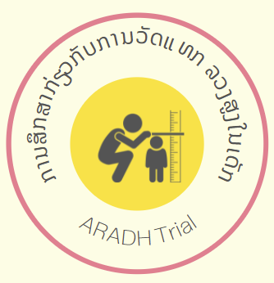
Assessing the Reliability and Accuracy of a Digital Ultrasonic Height measurement device on children aged two to five years in the Lao People’s Democratic Republic (The ARADH Study)

Protocol Version: #3 Date: 8 April 2022

Sponsor:
Burnet Institute

Confidential:
The document is confidential and the property of the investigators for conducting the study: Ms Shan Huang (Global Health Specialist, Burnet Institute)/ Dr Tasmyn Soller (Paediatric Registrar) / Dr Alyce Wilson (Public Health Physician and Senior Research Fellow, Burnet Institute) / Dr Sayaka Horiuchi (Paediatrician) / Dr Sengchanh Kounnavong (Former Director General and Paediatrician, Lao Tropical Public Health Institute) / Mr Paul Agius (Applied Statistician and Senior Fellow, Burnet Institute) / (Associate Prof Joshua Vogel (Principal Research Fellow, Burnet Institute)
Statement of Compliance:
This document is a protocol for a clinical research study. The study will be conducted in compliance with this protocol, the conditions of ethics committee approval, the NHMRC National Statement on Ethical Conduct in Human Research (2018) and the Note for Guidance on Good Clinical Practice (CPMP/ICH/135/95).

Institutions involved in the trial:
Burnet Institute
85 Commercial Rd, Melbourne
Victoria, Australia

Lao Tropical and Public Health Institute
Samsenthai Road, Ban Kaognot
Sisattanack district Vientiane Capital, Lao PDR

Executive Summary:
Anthropometric measurements such as height and weight are particularly vital in children. These measurements are a key element of growth and nutrition assessment ¹. Taking correct height measurements is necessary for accurate nutrition surveillance in low- and middle-income countries where this data is used to assess the nutrition status of its populations. For decades, the measurement board (made of wood or plastic) has been used by global agencies to measure recumbent length and height of children ¹. This tool has been found to be difficult to carry and their accuracy is found to be inconsistent. We propose the use of a digital measurement device using ultrasonic technology in place of the measurement board. We will test this in a low resource setting in rural Lao with health workers as the end-users of the product to take standing measurements from children between two to five years. Our study aims to validate this digital ultrasonic device against the current status quo as well as evaluate the device for usability among the end-user group (health care workers).

Background:
The use of basic anthropometric measurements, such as height and weight, have long been the standard indicators against which childhood nutrition status is assessed^{2,3,1}. These two, common anthropometric measures are used to calculate subnational, national and international estimates of undernutrition and overnutrition. This is particularly true in low- and middle-income countries (LMIC), where routine nutrition and anthropometric assessments are regularly performed for children aged 0-5 years¹. Estimation of the burden of stunting (low height-for-age) and wasting (low weight-for-height) in children under five years at a population level thus depend on accurate height and weight measurement in individual children⁴.
According to the World Health Organization, ‘childhood stunting is one of the most significant impediments to human development’⁵. It is a major public health concern in LMICs and is a condition that begins in utero and may continue beyond the early years of the child’s life; the condition is irreversible once established⁶. Stunting is a crucial in the impact measurement to trigger public health interventions, such as that of Sustainable Development Goal Two: Zero Hunger, of which stunting is the first indicator⁷. In addition to stunting, which is often caused by chronic undernutrition, the length/height of a child is also used to measure wasting, caused by more recent severe weight loss. If wasting is left untreated, it is associated with a higher risk of death in children⁸. The severity of the level of wasting, often determines the type of treatment prescribed to treat or prevent it, such as in the form of food supplementation for severe and acute malnutrition, or nutrition education programs for moderate wasting⁴.
While digital scales are routinely used to measure a child’s weight, height measurements are usually taken with measurement boards or stadiometers made of wood or plastic, making these instruments difficult to transport and prone to measurement error⁹. For decades, height/measurement boards have been used in anthropometric surveys to manually measure the length/height of an infant or child for the assessment of malnutrition in LMIC¹⁰. Between 2012 -2016, UNICEF procured over 130,000 measurement boards to the value of over USD 12.6 million¹¹. Thus, manual measurements taken using measurement boards are vital to providing reliable estimates of malnutrition in its surveillance and prevention. It is also essential to the monitoring and evaluation of the impacts of public health and nutrition interventions. According to the UNICEF procurement catalogue, the cost of measurement boards are USD 130 each¹².
However, plastic stadiometers and wooden measurement boards are difficult to transport, and prone to errors in reading and recording reliable height measurements in the field¹¹. A number of these challenges have been attributed directly to their design and use. These include the incorrect positioning of the child against the board, difficulty in seeing measuring tape etched onto the board, the incorrect angle at which the reading is read, as well as inter-observer variability¹¹. Children, particularly those aged under five years, are harder to measure due to their smaller size, and difficulty standing or lying still while measurements are taken¹³. The consequences of inaccurate measurements can lead to an under-recognition of malnutrition at individual or population level^{14,15}. This can, in turn, have profound negative consequences for a child’s lifelong health, and a lost opportunity to prevent avoidable morbidity.
The use of digital ultrasonic devices to measure length had been commonly used in the building and construction industry, however the application of these devices to measure length/height in paediatric settings has been developed, with very few well have been adequately reviewed or investigated. Several such devices are currently commercially available¹⁶⁻¹⁸, but little literature has been found around its use and it is unclear if any of these devices have been formally validated in a research setting, let alone, in a low resource setting. Digital height measurement devices that are currently commercially available range from USD 25-50 per unit¹⁶⁻¹⁸, and significantly cheaper than the measurement boards. If digital height tools were proved to be valid in field settings, using UNICEF procurement figures (2012-2016) potential cost savings would reach over USD 13 million.
In 2017, UNICEF issued a Target Product Profile (TPP) ¹¹ to call on industry partners to develop a height/length measurement device for use in nutrition surveillance and other similar activities undertaken by the organisation. Such a device needed to meet two requirements:
- Improvement to current available measurement boards with a digital output; and
- Using innovative technologies (such as ultrasound, infrared or laser).
Through a scoping review of the literature and currently available devices, our study team identified the One Grows™ device, marketed for measuring the length and height of children for personal use to track a child’s growth. This handheld ultrasound device is designed for use in the family home. The device meets both of the UNICEF TPP requirements and several optional requirements including an associated mobile application/app whereby the measurement taken by the device is automatically entered via Bluetooth technology. The app also allows for multiple measurement on multiple children. Other, similar ultrasonic digital height measurement devices are also currently available but either 1) not linked to an app; 2) not yet available on the market or 3) not available or suitable for use in the LMIC context.

2. Study Setting:
The Lao Democratic People’s Republic is a small landlocked country in South-East Asia. Burnet Institute has long-standing working relationship with Lao health and medical research partners and authorities. Lao also has one of the highest rates of malnutrition among children in the region - according to the latest 2017 Lao Social Indicator Survey, almost 11% of the population is under five years old, one-third of which are stunted (low height-for-age), 21% are underweight (low weight-for-age, and 9% are wasted (low weight-for-height)¹⁹. Tackling malnutrition is a public health priority for Lao, with the most recent National Nutrition Strategy (2015 – 2020) ²⁰ outlining several strategic objectives to achieve this.
One strategic objective is to improve nutrition surveillance systems to monitor the outcomes of nutrition implementation. Currently, nutrition surveillance is done periodically every few years in nationwide surveys or programmatically in target communities through government or non-government organisations. The data relating to the height, weight and age of children is currently collected using digital scales and a portable measurement board. These data are used by local provinces and health authorities to identify areas of concern to target local nutrition improvement programs. Locally, the proactive identification of malnutrition is done in the form of screening when a child is presented to a health facility. A trained health worker then takes the height and weight measurements using digital scales and a stadiometer or measurement board. Some districts may also undertake community wide nutrition screening during outreach event (such as during immunization campaigns or Vitamin A supplementation campaigns).
To improve the accuracy of children’s height measurements, a crucial element of nutrition surveillance and screening, we propose to explore the use of an ultrasonic digital height measurement device in the district hospital of the rural Feung district of Vientiane Province in Lao People’s Democratic Republic (Lao PDR). The district hospital and health centre we have chosen to test the digital ultrasonic height measurement device, offer a range of public health initiatives, including routine immunization and Growth Monitoring Promotion (GMP). Such a location is ideal for validating these devices while streamlining testing into routine health promotion activities.

3. Study Rationale:
Obtaining accurate anthropometric data collection is essential for identify children at risk of stunting and wasting in LMICs such as Lao PDR, as well as estimating the population-level burden of malnutrition. While plastic stadiometers and wooden measurement boards are commonplace in Lao child nutrition screening activities, they can be challenging to use in the field and have high cost. Digital ultrasonic devices are now available for measuring children’s height and are available at lower cost. If shown to be valid and acceptable in Lao, these devices could have an important role in anthropometry measurement in other, similar settings. In this study, we will assess the use of this commercially available ultrasonic digital height device in a LMIC setting as a tool for measuring the height of children aged 2-5 years, in the context of assessing nutrition and growth development status.

4. Aims, hypotheses and objectives:
The aim of this study is to assess the validity and acceptability of using an ultrasonic digital height measurement device on standing children aged 2-5 years in the Lao PDR. The study will test the use of this device in a rural setting, to help determine whether ultrasonic digital height devices are 1) suitable for use in a limited-resource context for the purposes of nutritional assessment in children and 2) equally valid compared to the current height measurement instruments used in Lao and other, similar LMICs.
We hypothesise that this device will alleviate the difficulties end-users (namely health workers and nutrition surveyors) face in measuring child’s height, such as improving the ease of transport, addressing challenges in recording measurements, greater affordability, and accuracy.
The specific objectives are:
- to assess the validity of an ultrasonic digital height device for measuring child height against the current reference standard, the wooden/plastic measurement board.
- to explore healthcare workers’ perspectives on usability of the ultrasonic digital height measurement device.

4. Methods:

4.1 Study Design
We will conduct a method-comparison study²¹ in the district of Feung. A group of eight healthcare workers (HCWs) currently working in health facilities will undergo a standardised training on how to use the ultrasound device and the measurement board.
Height measurements will be first taken using the ultrasonic digital device. Each time the measurer uses this device, the measurements are automatically recorded on a tablet device using the linked app. The data will then be transferred to the paper study data collection sheet immediately after the measurements are taken by the measurer.
Height measurements of the same children will then be taken using the standard wooden/plastic measurement boards. All measurements will be done by trained HCWs working in pairs in accordance with standard WHO guidelines, where one will be a measurer with the other the measurement recorder. Hence, the same measurer/HCW will measure the same child using both measurement tools.
Measurements will be recorded on a data collection sheet designed for the study (Appendix I).
The HCW will measure each standing child using the depicted process in Figure 1 below. Three measurements will be taken on each measuring device for the same child by the same HCW. All measurements taken will be averaged to identify a single, final measurement for each device. This final measurement will be used to compare and assess the validity of the ultrasonic digital height measurement device compared with the measurements taken from the same child using the measurement board²².
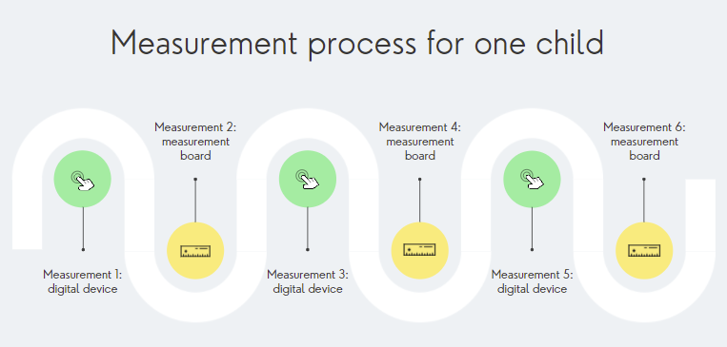
Figure 1: Measurement process flowchart
The level of agreement between the ultrasonic digital device and the measurement board will be assessed between all the measurements taken²³.
Additionally, the study will also seek to compare the usability of the ultrasonic digital device compared to the measurement board. A user survey based on the System Usability Scale (SUS) ²⁴ will be administered to the HCW with questions about their perceived difficulty of use for both instruments. The usability scale will quantify how well end-users interact with these two products ²⁴.

4.2 Study Site
The study will take place in the rural district of Feung in Vientiane Province. We will be using the day care centres of near Xangnoy, Nathong, Nankang, Laokham and Phonexay Kindergartens Kindergartens as measurement sites. The reason for choosing these sites is because child health activities - including routine community outreach for growth monitoring assessments, vitamin A and deworming campaigns - are frequently performed at day care centres in addition to health facilities in this district. As such, day care centres are a likely place where ultrasonic digital height devices will be used and is an ideal site for trialling this novel device in a LMIC setting. All day care centres involved in this study have similar confines, that is hard flooring and solid walls to ensure measurements are taken under similar conditions.

4.3 Population of interest (study participants)

4.3.1 Health care workers
Eight HCWs based at the Feung district hospital will be selected to participate in this study. This cohort of HCWs are most likely to be the end users of these devices in the public health setting, as opposed to anthropometric specialists.
In Lao PDR, such HCWs are trained as ‘Medical Assistants’ who undergo three years of tertiary level education. Some have the same qualifications as nurses or midwives but are responsible for public health activities such as maternal and child health promotion and nutrition screening in the community. The HCWs recruited for this study will undergo a standardized training on how to use the digital height measurement device correctly (further details in Quality Assurance and Training section below).

4.3.2 Children
Eligible children for this study will be those who are able to stand up unassisted, aged between 2-5 years. They may either attend the day care centres where measurements will be taking place or live in villages nearby the day care centres. They must have a parent or legal guardian that provides informed consent for their participation and be willing to participate in the measurement process. Children will not be mandated to participate if they find the measurements process daunting or uncomfortable.

4.4 Study Outcomes
- The primary outcome is to assess the validity of an ultrasonic digital height device (intervention) compared to a measurement board (reference standard).
- Secondary outcome is health care worker usability scale results for the ultrasonic digital height device when compared to the measurement board.

4.5 Primary Outcome Measurement Methodology

4.5.1 Standard measurement
The current measurements taken using a measurement board requires two HCWs and depends on the child’s age and ability to stand ²⁵. This study will use the method prescribed by the WHO Training Course on Growth Assessment ²⁵. For children aged two years and above, and who can stand, height is taken standing up with the child’s back to the measurement board. The height measurement is taken when the child is asked to stand up straight, barefoot on the baseboard with feet slightly apart. The back of the head, shoulder blades, buttocks, calves and heels all need to touch the vertical board. The child should not be leaning backwards or forwards but balanced at the waist. The mother/ caregiver is asked to hold the child’s knees and ankles to help keep the legs straight and feet flat on the board. The measurer will need to position the child’s head so that the eye line is horizontal to the board. Keeping the head fixed by holding the chin in that position with one head, use the other hand to lower the headboard to rest on the top of the head.

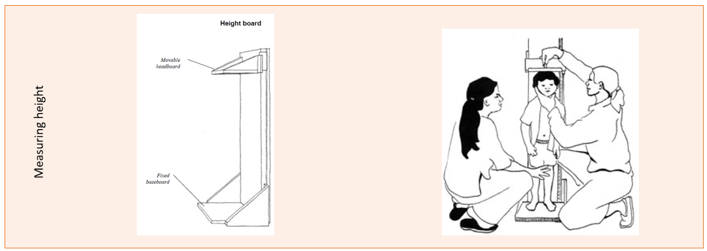
Figure 2: Visual representations of how child height measurements are taken from the WHO Training Course on Growth Measurement, 2008, pages 19-23.

4.5.2 Digital measurement
To measure height, the HCW uses a solid, smooth floor or hard ground surface (not carpeted or matted) against a perpendicular solid wall. The child stands against the wall with the back of the head, shoulder blades, buttocks, calves, and heels touching the floor. The digital height device is held with the base flat against the wall and the laser detectors facing towards the floor/ground. Once the device is firmly in position against the wall, the child can step away from the wall, the measurer presses the record button. After hearing the measurement being announced, remove the device from the wall to reveal the measurement displayed on the screen.

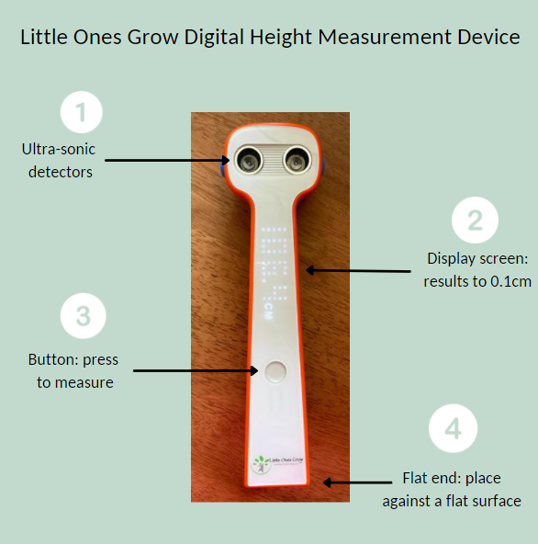
Figure 3: Aspects of the ultrasonic digital height measurement device used in this study (One Grows™)
Figure 4: Instructions for measuring height using the ultrasonic digital height measurement device

5. Recruitment:
We will recruit children who live in villages situated near Xangnoy, Nathong, Nankang, Laokham and Phonexay Kindergartens in Feung district, which will function as measurement sites. To minimise selection bias, any eligible children living in the villages nearby the measurement sites who meet the inclusion criteria will be invited to join the study, and if their parent provides informed consent, will be formally enrolled ²⁶, regardless of whether or not they attend the day care centre acting as a measurement site.
All children should meet the following inclusion criteria:
- are able to stand independently;
- aged between 2-5 years (inclusive);
- caregiver consent is received.
If a child whose measurement has been taken and found to have low height-for-age (stunted), the HCW will follow the national standard of care, which is to refer the child to a nutrition counselling service for treatment and advice in accordance with government protocol at a health facility. The parent/caregiver of the child may withdraw their child’s participation at any time by completing a Participant Withdraw Form (Annex II) and it will not affect the care they receive at the kindergarten/day care facility or any health facility in any way.
Recruitment of HCW into the study will be those working at nearby district hospitals who are responsible for health and nutrition screening activities and have previous experience with taking anthropometric measurements for height. The Lao TPHI team will recruit the HCW into this study with the approval from the District Health Department. They are well known to the health facilities in this area having involved them in similar studies previously. The Lao TPHI team will provide a verbal study orientation session to discuss study methods and device used with the District Health Department and associated HCWs. At this session, the HCWs will have an opportunity to handle the ultrasonic device, ask questions about the study and their participation in it. Interested HCWs will be invited to participate in the study at the end of the orientation session and provide their written consent to be involved (Appendix V). In total, eight HCWs will be recruited will undergo a standardisation test for manual anthropometry (specifically for height). Each HCW must pass the standardisation test to be recruited onto the measuring team. All HCWs participating in the study will undergo an additional training on study requirements, data collection and quality assurance. If at any point of the study, the HCW wishes to withdraw, they may do so by completing a withdrawal form (Appendix V).
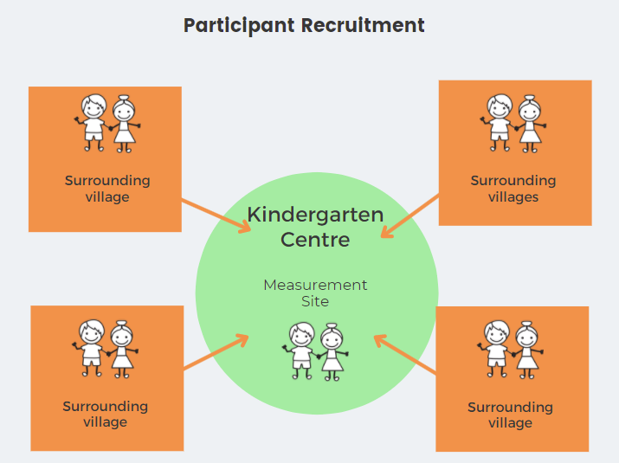
Figure 5: Graphic of child participant recruitment process

6. Consent and Ethical Considerations:
Ethics approval for this study will be sought in Australia through the Alfred Hospital Ethics Committee and in Lao PDR through the National Ethic Committee for Health Research, Ministry of Health. Ethics approval will be obtained prior to any study activities taking place.
The consent will be a two-part process. Group consent will be sought from local authorities (namely the Feung District Health Office and the associated Kindergarten Centres) by senior Lao TPHI prior to study implementation. An official letter of request will be sent by TPHI as the local implementing partner to the DHO and associated kindergartens asking them to participate in this study. Their agreements will then be agreed verbally with the TPHI team.
Individual informed consent will be sought from parents/caregivers prior to HCWs taking height measurements from their participating children. The Participant Informed Consent Form (PICF) is attached as Appendix II. In the cases where the child is attending the respective Kindergarten Centre, the consent form will be presented by HCW to the parent/caregiver the week before measurements is to take place. It will be read to the parents/caregivers, who will then provide their verbal and written consent to proceed with the measurements and subsequent data collection in the following week. For children who visit the Kindergarten Centre to have their child’s height measured, a consent form will be provided at time of recruitment.
Given that consent is sought from parents/caregivers by health care workers, we have explicitly outlined in the PICF that if the children do not wish to participant or withdraw from the study, it will not impact on their family’s ability to receive the same standard of care.
Implied consent from the HCW involved in using the measurement devices will be in place to administer in the SUS survey (Appenix III) for the secondary study outcomes.

6.1 Data Sharing
The consent form will include explicit extended consent for data sharing in keeping with current Australian legislation (Australian Privacy Principles of the Privacy Act 1988) which states that sensitive human and personal data cannot be shared in their original form. Should data resulting from this study be required to be made publicly available, we will re-identify these data. Re-identified data can be shared according to the respective legislation. This extended consent will include explicit consent for data sharing including the following elements:
- that data will be re-identifiable (coded), namely the facilities, health care workers, and children
- that this re-identifiable data will be used for planned analyses and publication, as well as potential future analyses
- that this re-identifiable data may be shared for additional, related analyses by legitimate researchers.

7. Data Collection:

7.1 Data Collection Form
The paper data collection form (Appendix I) will capture all measurements, as well as characteristics of the children involved (including age) as per Figure 1. The form will be translated and administered in Lao language. Digital data recorded by the ultrasonic device will be immediately transcribed onto the paper data collection form after each measurement. The recorded measurements from the measurement board will also be directly recorded onto this data collection form. There will be one form for each child measured. All forms completed will be collated at the end of each day and be scanned by the field supervisor and saved onto a secure project computer held by the Field Supervisor.
The SUS questionnaire (Appendix III) will also be translated and administered in Lao language for the participating HCWs. All forms completed will be collated at the end of the data collection period for child height measurements and be scanned by the field supervisor and saved onto a secure project computer held by the Field Supervisor.

7.2 Data Management and Security
The paper (hard copy) data forms will be collated and stored in a locked filing cabinet at the measurement site. Once the data collection is completed, the hard copies of all forms will be relocated to a secure location in the TPHI office and be kept for 5 years according to their institutional policy. The digital data that is automatically collected on the One Grows™ App which is linked to the ultrasonic device will be initially stored onto a 7-inch Samsung Galaxy A tablet provided with restricted passcode access. At the end of the study, this digital data will be permanently erased from the tablet device and the device will be reset to factory settings.
At the end of each day (for height measurement forms) and at the end of the study (for SUS forms), all the data from the hard copies will be transferred into a digital database created on REDCap (Research Electronic Data Capture) online by the Field Supervisor who will be trained on data entry using this platform.
REDCap is an open-source online software that is often used for data collection. The Burnet Institute hosts the REDCap application servers and associated database, which are securely housed (physically) in limited access data centres in Melbourne, Australia. They are maintained by the Burnet Institute’s Information Technology team. All web-based interaction (data entry, data submission, data synchronisation) with REDCap is protect via Secure Sockets Layer (SSL) encryption. Only the study team will have access to the database and are provided with usernames and passwords and will periodically authenticate with two-factor authentication.
Only the Australian Research team and the Lao TPHI team will have access to the REDCap database.

8. Quality Assurance and Training:
The HCWs recruited for the study will participate in a one-day training workshop at the Feung district hospital. A team from the Lao Tropical Health Institute (TPHI) personnel based in Vientiane Capital, with significant experience in taking anthropometric measurements and training, will deliver the workshop with technical guidance. The trainers will be supported by a Public Health Nutritionist from Australia with over 10 years work experience in the Lao context. The training materials used in this workshop will be co-developed between the Lao and Australian teams. These will include training videos on how to use the novel digital height device, accompanying user instructions and troubleshooting, as well as laminated instructional cards to guide them on the correct use of the digital device throughout the duration of the study period.
Eight HCWs from the Feung district hospital will be invited to attend the training. These HCW will be selected based on previous experience taking anthropometric measurements from children, and willingness to participate in this study. Each participating HCW will undergo training and a standardisation test for manual anthropometry using the measurement board and the ultrasonic digital height device at the Feung district hospital training facility. During the training they will take repeated measurement of ten standing children between two to five years of age. The standardisation test results will be compared with the mean of the 10 measurements from each of the HCWs results with that of the anthropometry lead from the TPHI team (who has significant training and practical experience). For reliability of measurements, we will calculate the Technical Error of Measurement (TEM) which is a way of assessing consistency and accuracy of measurements²⁷. All eight HCWs must pass the standardisation test to be involved in the study. The standardisation test will be repeated until the HCWs passes.
A Standard Operating Manual will also be provided. The contents of this manual will include standard procedures for:
- an operational protocol for data collection;
- plain language statements;
- the consent form to be administered;
- the written and graphic instructions on how to use both height measurement devices, and related troubleshooting;
- examples of correct and incorrect data recording;
- correct data handling and storage;
- space for field notes.
A nominated TPHI personnel will act as the Field Supervisor and will stay with the HCW teams for the duration of the data collection period to ensure proper administration of the operational protocols and data quality. Ongoing monitoring and evaluation will be done on a weekly basis through the management of data collected by the Lead Investigator. Scanned copies of the Data Collection Form will be sent via WhatsApp to the Lead Investigator and the Lao Team Leader at the end of each week. WhatsApp is an end-to-end encryption instant messaging platform that allows study data to be send to the investigative team while observing data privacy. A communications feedback loop will be managed between the Lead Investigator, the TPHI Field Supervisor and the HCWs to troubleshoot any issues that arise throughout the study period to be address in a timely manner.

9. Site Set Up:
Measurements sites at each of the day care centres have the same physical conditions. All centres have rooms that have concrete walls and flooring, suitable for the ultrasonic device. Measurements will be taken in a common room where space will be cleared for the measurement process and HCW team. The common room will also be supervised by the day care centre teachers when measurements are taking place. Other children playing in this area will also be present, mimicking a similar environment and conditions under which routine health outreach activities are performed by HCWs.

10. Statistical Considerations:

10.1 Statistical accuracy / power
According to the 2017 UNICEF Target Product Profile (TPP) ¹¹ the accuracy of a portable height measurement device should be within ±0.3cm. We will use this level of precision as the maximum allowable variation between the ultrasonic digital device and the measurement board measurements and therefore this will define agreement between the two measurement devices. The study will have capacity to recruit approximately n=220 study participants. With this sample size and clinical delta (±0.3cm); assuming a zero mean bias, 80% power, 95% confidence level and 10% attrition/missing data, the study will be able to provide statistical inference for an approximate maximum standard deviation of the difference in measurements between methods of 0.127cm or in other words an approximate 95% limit-of-agreement between the two measurement methods of 0.249cm. If there is greater observed mean bias in the measurement differences, the observed maximum standard deviation of the differences must be lower in order to provide inference at the levels stated above (e.g. for mean bias = 0.1cm, SD = 0.087cm or 95% LoA = 0.171cm).

10.2 Statistical analysis
For the primary outcome, we will analyse inter-device data to test the accuracy of the ultrasonic digital height device by comparing its results with the measurement board.
Bland-Altman plots and associated estimation of 95% limits-of-agreement (95% LOA) and coefficients of repeatability (CR) with 95% confidence intervals (95% CI) will be produced to quantify the levels of agreement between the digital device and measurement board ²⁹. These plots will depict bias and the level of agreement between the devices and will represent the extent to which differences in measurement fall within the maximum allowable difference of ±0.3cm (see figure 5 depicting the limits without data points). If the limits-of-agreement fall within the maximum allowable difference as stipulated by the UNICEF TPP¹¹, we will consider the two devices to be in agreement, descriptively. Additionally, linear mixed modelling (LMM) on nested repeated measures data (i.e. multiple device/method and multiple HCW measurements for a single child) will be used to estimate and compare the relative levels of between-HCW pair, between-child and between-device/method heterogeneity in height measurement. All analyses will be undertaken using the Stata statistical software package.
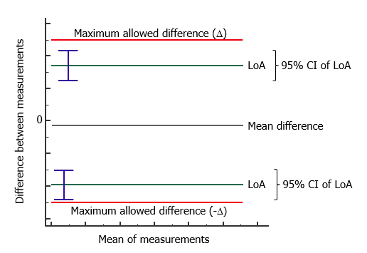
Figure 6: Depiction of the 95% confidence intervals (CI) of the Limits of Agreement ²⁸ and their relationship to the maximum allowed difference (Source: https://www.medcalc.org/manual/bland-altman-plot.php, accessed 18 Feb 2022)

For our secondary outcome, we will analyse, compare and tabulate the results of the user satisfaction surveys for both devices for quantitative usability data. The SUS data will be analysed whereby the HCW’s responses for each questionnaire item are scored, which are then derived to achieve a composite scale score (0-100 point scale). To determine usability prevalence, percentile rankings³⁰ will be estimated from participant composite SUS scores and the distribution explored . In previous SUS studies, a 70th centile score is considered a “good” usability experience.

11. Study Governance:
A Study Steering Group (SSG) will oversee all aspects of the study including design, implementation and evaluation. It will be chaired by the Chief Investigator Shan Huang and comprise of Joshua Vogel, Alyce Wilson, Tasmyn Soller, Sayaka Horiuchi and the Lao Counterpart (Sengchanh Kounnavong). The SAG will meet fortnightly in the first 2 months to set up the study and them monthly throughout its implementation.
The Implementation Committee (IC) will comprise of the representatives of the participating HCWs and district health staff to provide input into the recruitment process and implementation. The IC will be chaired by the Chief Investigator and weekly during the study implementation period to 1) monitor the progress of data collection, 2) explore any unintended effects of the study and 3) troubleshoot any unforeseen events that may affect study implementation.

12. Dissemination of results:
The results will be disseminated at different levels: the HCW team; the TPHI team; and the Burnet Institute. Findings will be presented to the Burnet Institute, Lao implementing partners and the local communities involved at the end of the study period. A publication of the study will be prepared for submission to a peer-review journal. Results may also be presented at relevant public health conferences in Australia, Lao PDR and globally. A plain language summary of the findings will also be presented to the community.

13. Milestones:
The following milestones are indicative of the timeline for this project but are subject to local COVID-19 restrictions and regulations in Lao PDR.
Milestone: | Mar | Apr | May | Jun | Jul | Aug | Sept | Oct
Ethics Submission (in Australia and in Lao) | X | X
Ethics Approval |  |  | X
Training Material Development (incl. translation) |  | X | X
Training Workshop |  |  |  | X
Data Collection |  |  |  | X
Data Cleaning and Analysis |  |  |  |  | X
Results Dissemination |  |  |  |  |  | X
Manuscript preparation |  |  |  |  |  |  | X
Manuscript finalised for publication |  |  |  |  |  |  |  | X

14. Budget:
Item: | Quantity and Unit: | Cost:
Ethic Application | 2 | $450
Device procurement ³¹ | 4 units (TBC) | $300
Training workshop ³¹ | 1 | $200
Training material printing | 3 sets | $5
Instructional card printing | 6 sets | $45
Participation reward for children | 220 | $250
Lao TPHI personnel (3) | 4 days | $400
Travel and accommodation costs during data collection | 20 days | $600
Burnet personnel | 5 days | $2750
TOTAL |  | $5000

- Device procurement includes purchase of the digital height measurement devices and shipping costs to Lao PDR,
- Cost for training workshop includes per diem for two trainers and six trainees plus venue and catering costs,
- Lao TPHI personnel includes Study Lead (Dr. Sengchanh Kounnavong), Study Coordinator (Dr. Khampheng Phongluxa), Training and Data Coordinator (Dr. Kethmany Ratsavong) and Field Supervisor (Dr.Phoyphailin Prasomsouk).

Acronyms:
CI Confidence Intervals
CR Coefficients of repeatability
GMP Growth Monitoring Promotion
HCW Health Care Worker(s)
HTTPS Hypertext Transfer Protocol Secure
IC Implementation Committee
LMIC Low- Middle-Income Countries
LMM Linear Mix-Modelling
LoA Limits of Agreement
PDR People’s Democratic Republic
PICF Participant Informed Consent Form
SSG Study Steering Group
SUS System Usability Scale
TEM Technical Error of Measurement
TPP Target Product Profile
TPHI Tropical Public Health Institute of Lao
UNICEF United Nations Children’s Fund
USD United States Dollar
WHO World Health Organization

References:

1. World Health O, United Nations Children's Fund. Recommendations for data collection, analysis and reporting on anthropometric indicators in children under 5 years old. Geneva: World Health Organization; 2019.
2. Grellety E, Golden MH. The Effect of Random Error on Diagnostic Accuracy Illustrated with the Anthropometric Diagnosis of Malnutrition. PLoS One 2016;11(12):e0168585.
3. Laar ME, Marquis GS, Lartey A, Gray-Donald K. Reliability of length measurements collected by community nurses and health volunteers in rural growth monitoring and promotion services. BMC Health Serv Res 2018;18(1):118.
4. Ickes SB, Craig C, Heidkamp R. Design Factors for Food Supplementation and Nutrition Education Interventions That Limit Conclusions about Effectiveness for Wasting Prevention: A Scoping Review of Peer-Reviewed Literature. Advances in Nutrition 2021.
5. World Health Organization. Global nutrition targets 2025: stunting policy brief. 2014 [cited 2021 9 November]. Available from: https://www.who.int/publications/i/item/WHO-NMH-NHD-14.3
6. Georgiadis A, Penny ME. Child undernutrition: opportunities beyond the first 1000 days. Lancet Public Health 2017;2(9):e399.
7. United Nations. The Sustainable Development Goals Report. New York, NY: United Nations; 2021.
8. World Health Organization. Malnutrition. World Health Organization; 2021 [cited 2021 9 November]. Available from: https://www.who.int/news-room/fact-sheets/detail/malnutrition
9. Conkle J, Suchdev PS, Alexander E, Flores-Ayala R, Ramakrishnan U, Martorell R. Accuracy and reliability of a low-cost, handheld 3D imaging system for child anthropometry. PLoS One 2018;13(10):e0205320.
10. Bauman A, Ernst K, Hayden M, Roe DJ, Murray R, Agawo M, et al. Assessing Community Health: An Innovative Tool for Measuring Height and Length. Journal of tropical pediatrics 2018;64(2):146-50.
11. United Nations Children's Fund. UNICEF Target Product Profile: Height/length Measurement Device(s). 2017.
12. United Nations Children's Fund Supply Division. Portable baby/child/adult length measurement system. New York, NY: United Nations Children's Fund,; 2018 [cited 2021 10 November]. Available from: https://supply.unicef.org/s0114520.html
13. Yorkin M, Spaccarotella K, Martin-Biggers J, Lozada C, Hongu N, Quick V, et al. A Tool to Improve Accuracy of Parental Measurements of Preschool Child Height. Advances in Public Health 2015;2015:965371.
14. Pullum TW, Allen C, Namaste S, Croft T. The Sensitivity of anthropometric estimates to errors in the measurement of height, weight, and age for children under five in population-based Survey. Rockville, Maryland, USA: ICF; 2020.
15. Conkle J, Ramakrishnan U, Flores-Ayala R, Suchdev PS, Martorell R. Improving the quality of child anthropometry: Manual anthropometry in the Body Imaging for Nutritional Assessment Study (BINA). PLoS One 2017;12(12):e0189332.
16. AliExpress. Digital Ultrasonic Height Measuring Ruler Precision Measuring Device Adult Kids E7CB. 2022 [cited 2022 19 February]. AliExpress sale notice]. Available from: https://www.aliexpress.com/item/4000945500834.html?_randl_currency=AUD&_randl_shipto=AU&src=google&src=google&albch=shopping&acnt=708-803-3821&slnk=&plac=&mtctp=&albbt=Google_7_shopping&albagn=888888&isSmbAutoCall=false&needSmbHouyi=false&albcp=9604210690&albag=100463787298&trgt=313429380675&crea=en4000945500834&netw=u&device=c&albpg=313429380675&albpd=en4000945500834&gclid=CjwKCAiAx8KQBhAGEiwAD3EiP2XZo2kPLgjVIyBIjEYA3-b_gLn01XZQHDbWlR8b4keWDSdvt-kr5hoCbVgQAvD_BwE&gclsrc=aw.ds&aff_fcid=033f652edd4d42c3b4895b2c696a3e57-1645267468205-08339-UneMJZVf&aff_fsk=UneMJZVf&aff_platform=aaf&sk=UneMJZVf&aff_trace_key=033f652edd4d42c3b4895b2c696a3e57-1645267468205-08339-UneMJZVf&terminal_id=47ee2f0b5db4459189bc7884663bf55b&afSmartRedirect=y
17. Australia A. Hashy Giraffe Digital Wireless Body Height Meter Ultrasonic Height Measuring Instrument Stature Fast Meter For Kids Measuring Moving Height Ruler. 2022 [cited 2022 19 Februrary]. Amazon sale notice]. Available from: https://www.amazon.com.au/Hashy-Wireless-Ultrasonic-Measuring-Instrument/dp/B07WX7L5TM/ref=asc_df_B07WX7L5TM/?tag=googleshopdsk-22&linkCode=df0&hvadid=540211181902&hvpos=&hvnetw=g&hvrand=15015573022282604586&hvpone=&hvptwo=&hvqmt=&hvdev=c&hvdvcmdl=&hvlocint=&hvlocphy=9071309&hvtargid=pla-1599882403177&psc=1
18. Australia e. Digital Ultrasonic Height Measuring Ruler Precision Measuring Device Adult Kids. 2022 [cited 2022 19 February]. eBay sale notice]. Available from: https://www.ebay.com.au/itm/254834252135?chn=ps&_ul=AU&_trkparms=ispr%3D1&amdata=enc%3A12MCTszVbQHSqwTzUJE_4BQ6&norover=1&mkevt=1&mkrid=705-139619-5960-0&mkcid=2&itemid=254834252135&targetid=1597821229585&device=c&mktype=pla&googleloc=9071309&poi=&campaignid=14474119807&mkgroupid=127424473355&rlsatarget=pla-1597821229585&abcId=9300653&merchantid=494542047&gclid=CjwKCAiAx8KQBhAGEiwAD3EiP-hEtlIJi2Wi8gyL2Li0RE5OARJHtBLbo8uSi8qHzJgH87BvZGMBxBoCWi4QAvD_BwE
19. Laos Statistics Bureau. Lao Social Indicator Survey II 2017, Survey Findings Report. Vientiane, Lao PDR: Lao Statistics Bureau and UNICEF; 2017.
20. Government of Lao. National Nutrition Strategy to 2025 and Plan of Action 2016-2020. Committee NN. Vientiane, Lao PDR; 2015.
21. Hanneman SK. Design, analysis, and interpretation of method-comparison studies. AACN Adv Crit Care 2008;19(2):223-34.
22. Glock F, Vogel M, Naumann S, Kuehnapfel A, Scholz M, Hiemisch A, et al. Validity and intraobserver reliability of three-dimensional scanning compared with conventional anthropometry for children and adolescents from a population-based cohort study. Pediatr Res 2017;81(5):736-44.
23. Syafiq A, Fikawati S. Reliability and validity test of digital infant length measurement board with sonar sensor precision. Malays J Nutr 2013;19:303-9.
24. Kortum PT, Bangor A. Usability Ratings for Everyday Products Measured With the System Usability Scale. International Journal of Human–Computer Interaction 2013;29(2):67-76.
25. World Health Organization. Training Course on Growth Assessment. Geneva, Switzerland: World Health Organization; 2008.
26. Hammer GP, du Prel J-B, Blettner M. Avoiding bias in observational studies: part 8 in a series of articles on evaluation of scientific publications. Deutsches Arzteblatt international 2009;106(41):664-8.
27. de Onis M, Onyango AW, Van den Broeck J, Chumlea WC, Martorell R. Measurement and standardization protocols for anthropometry used in the construction of a new international growth reference. Food Nutr Bull 2004;25(1 SUPPL. 1):S27-S36.
28. Carsley S, Parkin PC, Tu K, Pullenayegum E, Persaud N, Maguire JL, et al. Reliability of routinely collected anthropometric measurements in primary care. BMC Med Res Methodol 2019;19(1):84.
29. Bland JM, Altman DG. Statistical methods for assessing agreement between two methods of clinical measurement. Lancet 1986;1(8476):307-10.
30. U.S General Services Administration TTS. System Usability Scale (SUS). U.S General Services Administration; 2022 [cited 2022 2 March]. Available from: https://www.usability.gov/how-to-and-tools/methods/system-usability-scale.html
31. Cheikh Ismail L, Knight HE, Bhutta Z, Chumlea WC, International F, Newborn Growth Consortium for the 21st C. Anthropometric protocols for the construction of new international fetal and newborn growth standards: the INTERGROWTH-21st Project. BJOG : an international journal of obstetrics and gynaecology 2013;120 Suppl 2(0 2):42-v.

