Funnel plot for meta-analysis of PRL levels in GDM vs non-GDM control women in early pregnancy (≤24 weeks) – 3 studies
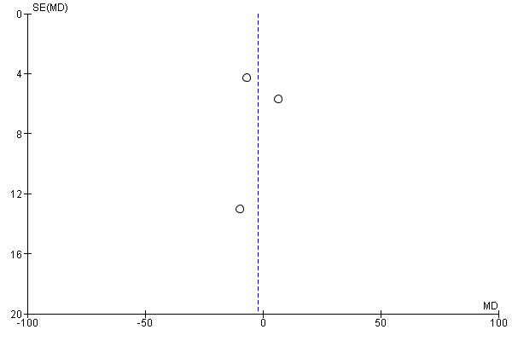
Funnel plot for meta-analysis of PRL levels in GDM vs non-GDM control women in late pregnancy (>24 weeks) – 11 studies
