Tracking tunnel cards
Calculating the proportion of the card that has been ‘footprinted' in Adobe PhotoShop 2020
1) Take photo of the tunnel card (both sides) on a black non-reflective background with scale. All pictures were taken with one cameras at 180ppi:
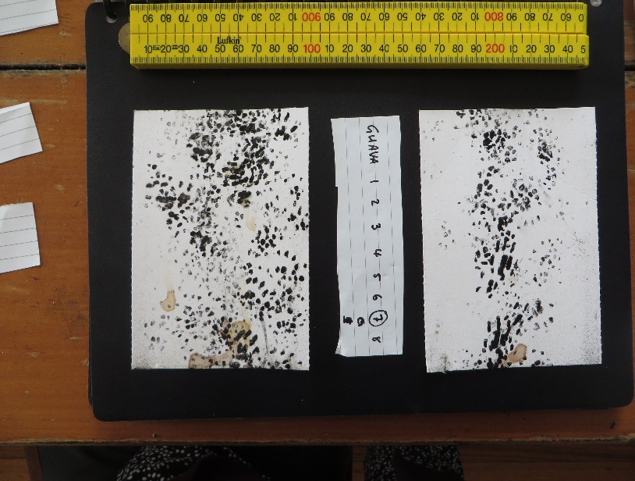

2) Create two new images by close cropping side a and side b:
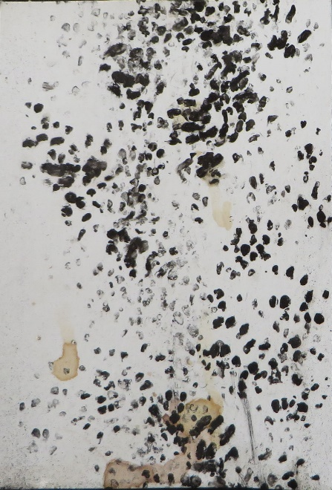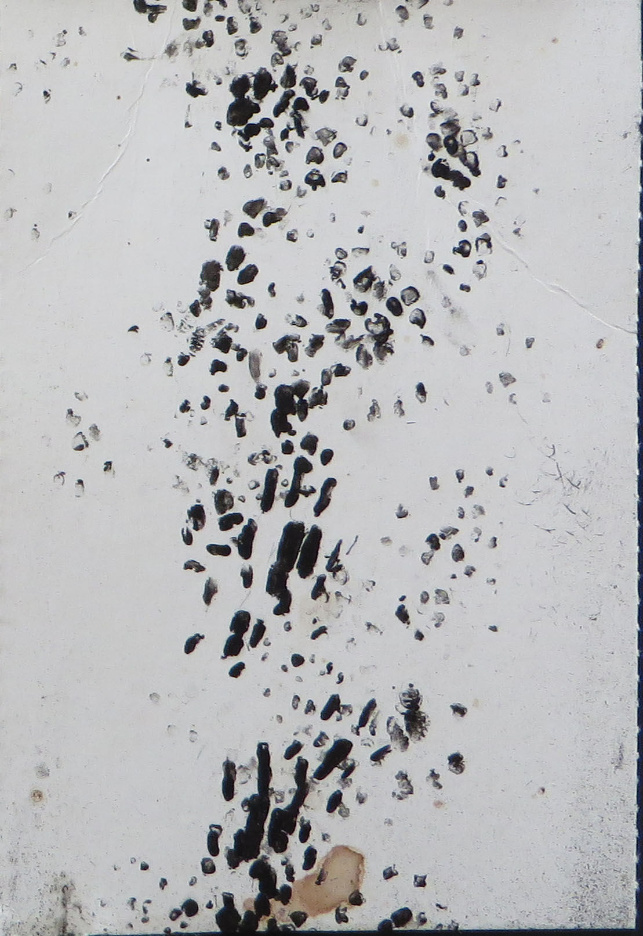

3) Analyse each image separately. Resize all images to 1400 x 2100 pixels. For each image, overlay an 8 x 12 grid. Do this by:
b) creating a new document the size of a single grid cell (175x175 pixels)
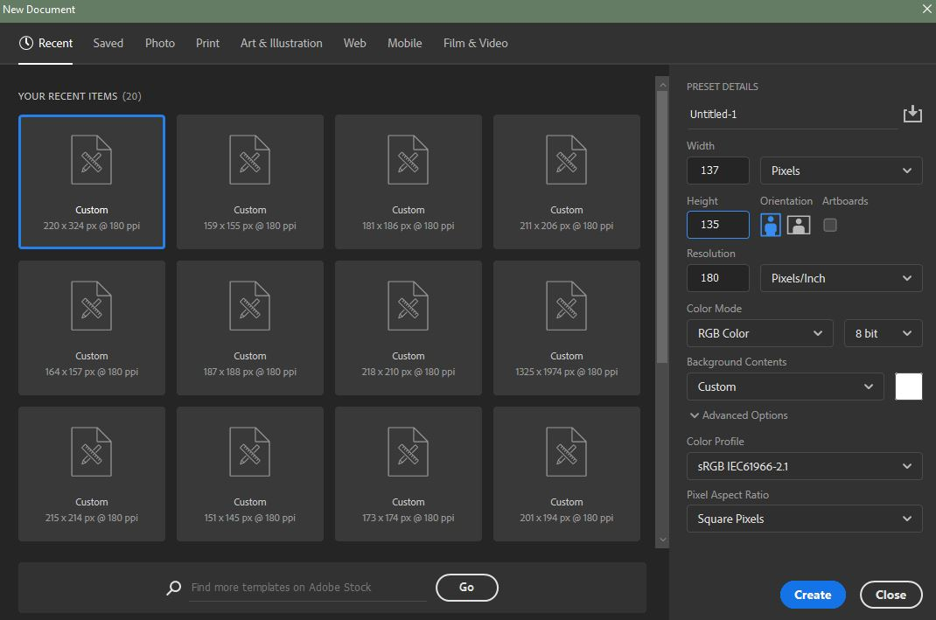
c) making a rectangle the length of the cell width and 5 pixels wide that then becomes a backwards-L shaped half border around the document
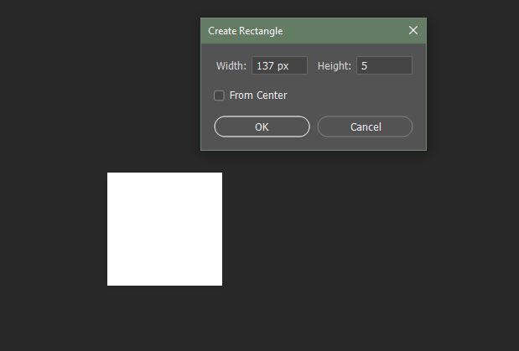
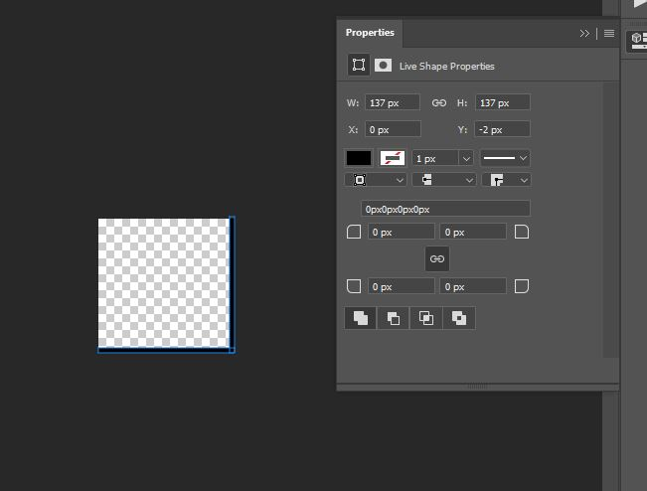
d) Define this as a pattern in the edit menu (using the pixel size and resolution)
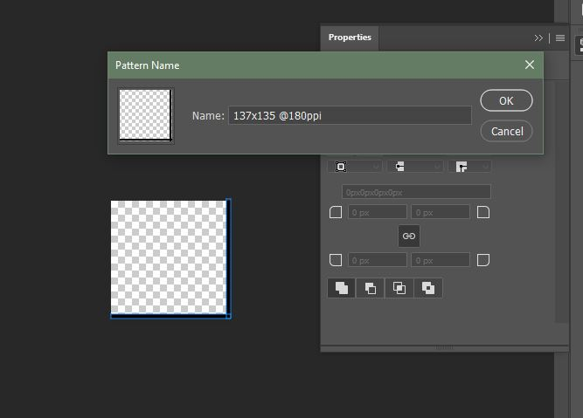
d) returning to the card image, overlay the pattern onto the image by clicking this icon then clicking ‘pattern’:
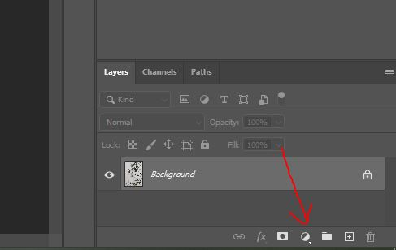
e) now you should have an 8x12 grid overlaying your image!
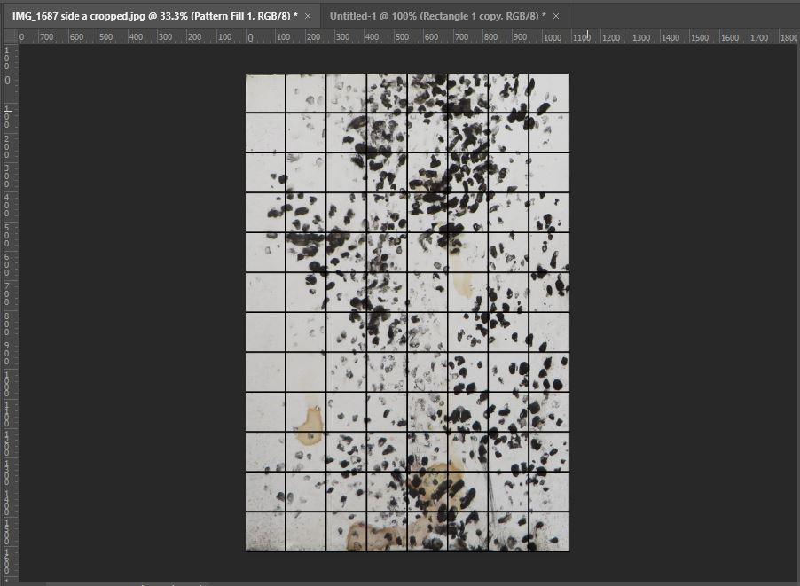
4) using the counter feature, click on each cell that has a minimum of two full toe prints within in. If there are only partial prints (i.e. prints that are partially within an adjacent cell) then they do not count as a full print. There needs to be at least two full prints within a cell for it to be defined as a ‘positive cell’. Full prints include those that are faint (because of less ink etc)
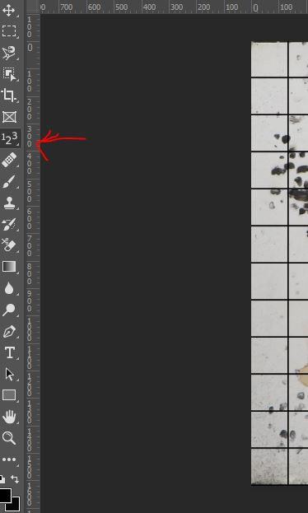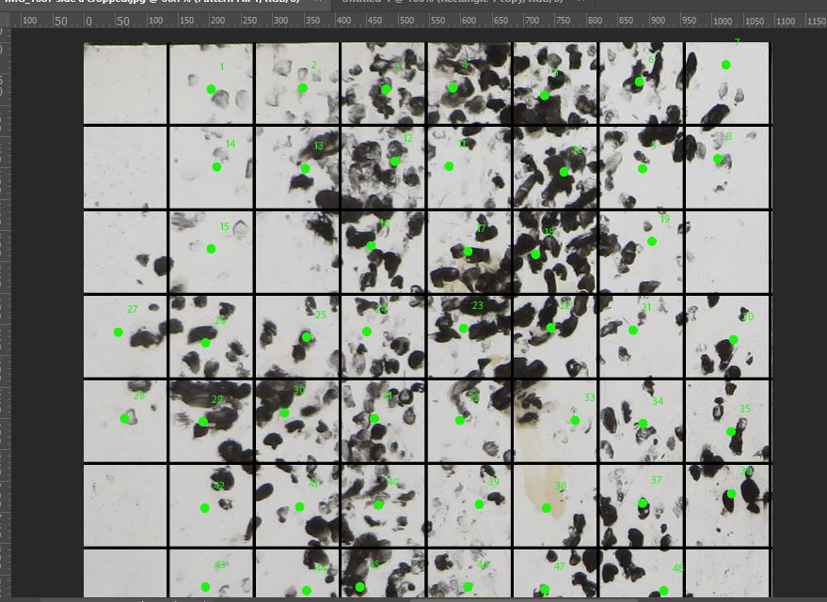
5) Once you have gone through the entire grid, double checked cells, and are happy with your counting look to the top left to find total counted cells
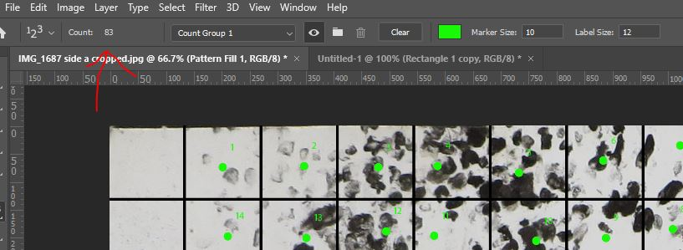
6) record this number and then do the same for the second side of the card. These data can then be calculated as ‘proportion positive cells’ by dividing the count of positive cells by the total number of cells in the grid. So in this instance 83/96 = 0.86458333.
7) Calculate proportion positive cells for each card as well as proportion positive cells for the combined cards so where P_{a}= positive cells for side a; P_{b} = positive cells for side b; T = total available cells per card the calculation is:
P_{a} + P_{b} /T_{a} + T_{b} = Proportion of positive cells of tunnel

