CBT
+ Light
for Women
with Breast Cancer

Email module 4.a
This email module includes information on relaxation and strategies to reduce feelings of stress and tension that often interfere with good sleep. We will also cover some techniques for sleeping with pain and physical discomfort.

Relaxation for your body

Tension, stress, and anxiety are common during breast cancer. In addition to these feelings of unease, tension also occurs around your body resulting in physical experiences which you may or may not notice.
For example:

- Shallow and/or fast breathing
- Holding your breath
- Tense neck and shoulder muscles
- Tension around your jaw
- Clenching your teeth
- Tightness in your back, arms, or leg muscles
Try-It-Now: Where are my tension spots?

Everyone experiences tension differently. Take a moment and ask yourself:

"Where in my body do I usually feel tension?"
"My breathing…? Certain parts of my body…shoulders, neck, jaw...?"

Keep these tension spots in mind. Check in on those places as often as you can, and relax them if you notice tension.

Click here to do a short mindfulness exercise to bring your attention to your body (1 min body scan)

Physical tension around the body sends “stress signals” to the brain, which then produce stress chemicals that further tense muscles, and quicken breathing, in preparation for dealing with stressful situations.

This vicious stress cycle often builds long before you even notice the physical feelings of being tense or on edge. Being tense and ready to deal with stressful situations is the exact opposite of sleep, so staying present and being aware of tension is an important first step towards relaxation.

Slow, natural, breathing, and relaxed muscles around your body, will help prepare your body for sleep. Practicing relaxation can help you achieve this.

1. Adjusting your breathing
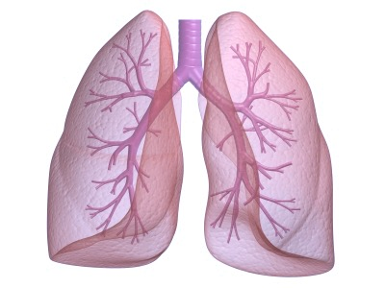
- Pay attention to how you breathe throughout the day and night, as often as you can. Remember, fast and shallow breathing, or holding your breath, can lead to a stress response.

- When you notice these signs, simply try to do the opposite:
Slow down your breath, take the in-breaths deeper,
all the way into your belly.

- Belly breathing (also known as abdominal or deep breathing)
is a healthy and efficient way to breathe, because it allows more air
to be utilized by your body.
Try-It-Now: Adjust Your Breathing

- Direct the air all the way down into your belly, so that your belly rises and falls, and not so much your chest.
- After adjusting your breathing, take a moment to notice the difference, so your mind can appreciate and register any difference.
- Try to maintain this calmer way of breathing, as long as you are able to, and return to it as of often as you remember.

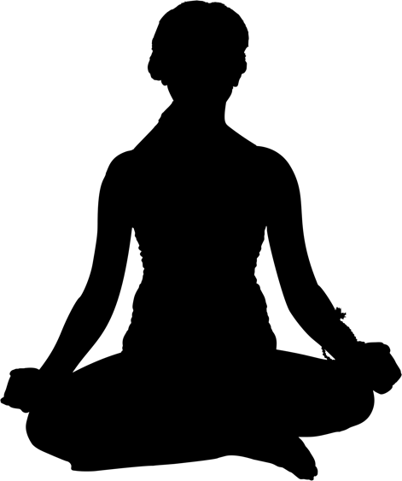
2. Letting go of tension in your body (also known as “Progressive Relaxation”)

- As you practice “Staying Present” (from last week’s email),
notice any tension you might hold in each part of your body,
progressively, from your head, through your torso and limbs,
to the tip of your toes.
- If you notice tension, such as a tense muscle,
focus your next breath slowly into that muscle,
and as you breathe out, let go of the tension.
- Notice the different sensations in your body as you
breathe in, and then let go of the tension, however small it may be.
- Repeat this as many times as needed.

Check in on your tension spots as often as you can, and relax them if you notice tension. They are shortcuts to relaxing your body

- When your body is relaxed, your mind will follow.
- Staying Present and Relaxation: Gifts to give yourself every day.
Sleeping with physical pain and discomfort
Physical discomfort and pain are common reasons for poor sleep during breast cancer treatment. Whilst these experiences are difficult and largely unavoidable, there are things you can do to reduce their impact on your sleep and mood.

Firstly, it is important to:
- Talk to your doctor to make sure you have the best pain medications to help you sleep.
- Consider ways to set-up your bed to minimise pain (extra pillows etc).
- Have pain medications (and drinking water) in easy reach of your bed.

How you think about pain/discomfort changes how much pain/discomfort you feel.
Yes, really!
Our natural response to pain and discomfort, is that "it feels terrible”, and we want to push it away. It might feel like a struggle every time we feel it. When it does not go away, and disturbs sleep, we might get upset and frustrated.
When we react to pain and discomfort as if they are our worst enemy, our body tends to become more tense, which can intensify the experience. Such reactions can also increase emotional distress, which also disturbs sleep. Strategies below can help you build a healthy relationship with pain and discomfort, so that when they are inevitable, their impact on you is reduced.

1. Instead of calling it “pain” or “discomfort” in your mind, call it a “sensation”. Remind yourself that the sensation might not be pleasant, but it does not mean that anything is wrong.
2. Whenever you notice unpleasant sensations:

Catch thoughts such as: Replace them with:
A gentle curiosity. Observe these sensations without labeling them as “terrible” or “bad”.
Remind yourself that reacting negatively to these sensations can magnify them, and you are trying to build a non-confrontational relationship with these experiences.

“I hate feeling this way”
“Oh, not again...”
“This will never end…”

3. Instead of pushing away or struggling with the sensation, practice being patient and willing to accept it.

You could take your mind and breath into the sensation. As you inhale, imagine creating space around it. You could say something like:

“This sensation is uncomfortable, I don’t like it, but I do have room for it”.

This can help you to switch off the struggle you may otherwise have with it, and free you up to focus on, and find pleasure in other things.

4. Breathe through it. Treating unpleasant sensations the same way you treat muscle tension – covered in the relaxation section above. Try breathing into places of discomfort and pain. As you breathe, let go of tension around that area. Notice any differences to the sensation, as you breathe in and out.

Click here for a longer body scan relaxation exercise (Body scan)
Reminders:

30 minutes of bright light each morning and dim light in the evening keep your clock tuned.
Using the light glasses when you feel tired or sleepy during the day promotes energy and alertness. Remember not to drive when wearing the glasses.

Go to bed only when you are sleepy. Catch the sleepiness wave as it comes, but not too much earlier than your usual bedtime.

Get up around the same time each morning.

If you struggle to fall asleep at night, stop trying. Get out of bed and do something relaxing and return to bed when the next sleepiness wave comes.

Try not to count the hours of sleep. Your body recharges sleep by sleeping deeper, and not necessarily longer.

