CBT
+ Light
for Women
with Breast Cancer
Email module 2
This email module will cover the differences between sleep deprivation and insomnia and how to cope with these experiences.

Insomnia Vs Sleep deprivation
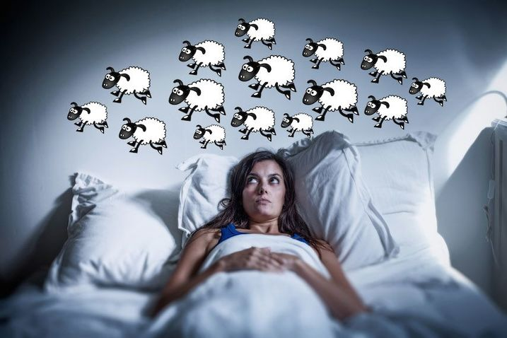
“Sleep Deprivation” and “Insomnia” are two different types of sleep problems experienced by women during breast cancer.
- Strategies to cope with these two problems
are different.
- Learning to tell the different between them
and apply the right strategies is an important aspect of this intervention.

Am I sleep deprived or experiencing symptoms of insomnia?

What is it?
Sleep Deprivation: Sleep deprivation happens when something in your physical environment (e.g., physical discomfort, chemotherapy related nausea, pain) prevents you from getting enough sleep. As you have learned previously, these experiences are very common during breast cancer.
Insomnia: Signs of insomnia may include difficulty falling asleep, waking up in the middle of the night or too early, and having difficulty falling back to sleep, even if you have the opportunity to sleep. Beyond not sleeping well, insomnia could also come with distress and anxiety about not sleeping well. When the severity of these signs reach a threshold, insomnia may become a persistent problem that needs treatment.

What do they have in common?
In both sleep deprivation and insomnia, you might feel you are not getting enough sleep, and you might feel tired, or moody or have difficulty concentrating during the day.

What are the differences?
Sleep Deprivation: You fall asleep quickly and sleep well when you have the opportunity to sleep (e.g. you aren’t currently experiencing pain, nausea, stress etc.)
Insomnia: Your sleeping difficulty persists even when you have the opportunity for sleep.
Sleep Deprivation: You may feel sleepy during the day, and could fall asleep easily when you have the opportunity to.
Insomnia: You may feel tired during the day, but not quite “sleepy”. Feeling “tired” means having low physical or mental energy. "Sleepy” means having to struggle to stay awake, yawning, or nodding off unintentionally. When insomnia is present it might be difficult to fall asleep when trying to nap during the day.
Sleep Deprivation: You may look forward to sleep opportunities. You are pretty confident that when things that prevent you from sleeping well are not around, you will get a good sleep.
Insomnia: You may be concerned about not being able to sleep, and may even feel anxious that when you go to bed, you might not be able to get enough sleep.
Sleep Deprivation: You may feel frustrated for not getting enough opportunity to sleep.
Insomnia: You may feel frustrated that despite trying, sleep does not come.
Strategies for insomnia - Stimulus Control
“Stimulus control” is one of the most important tools for improving sleep. It is particularly helpful when experiencing insomnia.
- Go to bed only when you are sleepy (that is, yawning, nodding off, struggling to keep your eyes open). This is one of the most important rule for good sleep. Sleep is hard to come by when you are alert. Following your body clock and riding the sleepiness wave when it comes will make it easier to fall asleep.

- Do not go to bed before your usual bedtime, even if you didn’t sleep well the night(s) before. Going to bed too early can disturb your body clock. Also, your body recharges sleep by sleeping deeper, and not necessarily longer.

- If you can’t fall asleep quickly (about 20-30 minutes), stop trying. If you keep trying hard to sleep, you might feel more frustrated, which makes it even harder to sleep. Instead, get out of bed, go into another room, and do something relaxing. While you are up, stay calm; remember, with every passing minute that you are awake, your body is accumulating sleep drive (i.e., “hunger for sleep”), which will help you fall asleep again. When the next wave of sleepiness comes, go back to bed and try again. You might need to do this many times a night, and it is okay! This strategy is scientifically shown to be very effective approach to overcome insomnia.
  - Please note – Stimulus control is not suitable to use during periods of hospitalization. It may also not be ideal if you are very unwell, if you are at risk of falls during the night, or if getting out of bed worsens pain. In these situations, instead of getting out of bed, sit up, keeps lights dim and engage in other activities until you feel sleepy enough to turn the lights off and go back to sleep.

- Do not look at the clock in the middle of the night (this will only wake you up even more). Set an alarm for the morning if you have to get up by a certain time, otherwise let your body and your mind tell you when it is time to get up. It is OK to simply estimate your sleep/wake times when completing your sleep diary.

- Get up around the same time every morning, and try not to sleep in, even if you had a poor night’s sleep. This helps keep your body clock in check.

Reminders:

Using light glasses every morning at your usual rise time, and when you feel tired and sleepy, will help you to feel more energized throughout the day and feel sleepy at night time

Remember to avoid caffeine, alcohol and nicotine before bed time.

Daily movement is beneficial for your body. If you can, find something that you find enjoyable such as yoga, walking, stretching, cycling or swimming, it could even be just walking around your garden watering plants.

Daily rhythms and routines are your body clocks friend. Bright light in the morning and Dim light in the evening keep your clock tuned.

