CBT
+ Light
for Women
with Breast Cancer

Email module 1
This email module includes an overview of the factors that determine how well we sleep and some healthy habits and attitudes toward sleep that we encourage you to practice throughout your breast cancer treatment.

Sleep during Breast Cancer – What to expect?

Symptoms of poor sleep are common following breast cancer diagnosis and throughout its treatment. Some women have sleep problems that start before cancer diagnosis, whilst some experience new or worsening sleep problems. Sleep problems can be ongoing for many years, even when treatment ends. Cancer patients are 2-3 times more likely to have sleep disturbances than the general population. So, if you are not sleeping well, you are not alone!

Generally, the following factors tend to cause sleep difficulties during breast cancer:

- Anxiety and stress
- Treatment side effects (pain, nausea, discomfort)
- Circadian rhythm (Body clock) disruption

Sleep problems are particularly common at the following times:
- Before and after diagnosis: The anxiety and stress of cancer diagnosis could make it difficult to fall asleep and stay asleep during the night. Other stressful times include: waiting for important appointments or test results, and going through times of change (e.g., worsening health, finishing treatment, returning to work etc.)
- Hospital admission.
- Chemotherapy: The physical impact and side effects of chemotherapy may make you feel unwell, and interfere with sleep. You may experience pain, nausea, vomiting, hot flushes, frequent toilet trips, itching, headaches, diarrhea, constipation, or fever.
- Steroids such as dexamethasone, prednisolone or hydrocortisone (often taken with chemotherapy) can make you feel agitated, restless, irritable or contribute to low mood.
- Hormonal or anti-androgen therapies may cause hot flushes, changes in mood or other side effects that can interfere with sleep.
- Pain medications may cause drowsiness, and lead to napping during the day.

Although we cannot remove some of the factors above, this program will give you strategies to reduce their impact on your sleep and wellbeing.
3 Factors work together to determine how well you sleep

- Sleep Drive (“hunger” for sleep)
Hunger for food increases with time since your last meal. Sleep drive is like “hunger for sleep”. It increases over the course of your day as you stay awake longer. A high level of sleep drive at bedtime supports a good sleep at night: It helps you fall asleep faster, and stay asleep longer.
When you nap or sleep, your level of sleep drive drops quickly. Just like a small snack can reduce your appetite for dinner, if you have trouble falling asleep, not napping during the day can help you save up sleep drive for nighttime sleep.

- Body Clock
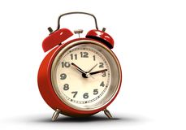
We all have an internal body clock that regulates our alertness across the 24-hour day-night cycle. It does this by increasing or decreasing alerting signals.
In the early morning hours: It starts sending alerting signals, and we tend to wake up 1-3 hours after the initial rise of the clock’s alerting signals.
During daytime (waking hours): the body clock sends alerting signals of increasing magnitude, so that despite an increased sleep drive we are able to still be awake.
At nighttime: It decreases the alerting signal, so as sleep drive keeps increasing it eventually becomes strong enough that we feel sleepy as bedtime approaches.
- Some people have an earlier body clock “morning larks”. They wake up in the morning, feeling alert and energetic.
- Some people have a later body clock “night owls”. In the morning they tend to feel they need to continue sleeping. They become more alert as the day progresses and feel most energetic in the evening.
- Most of us, however, have neither early nor late body clocks but somewhere in between, along a continuum.

Helping your body clock to best support your sleep:
- Wake up at about the same time every morning – so that your eyes get bright light at about the same time each day.
- Keep the lights dim in the evening – light can be alerting.
- Keep regular routines such as meal times, napping and exercise.

3. Active/ Quiet mind
- An active mind at bedtime makes it difficult to sleep, even when your sleep drive is strong, and your body clock is signaling it is a good time to sleep.
- Your body reacts as if you are still “on duty”, with increased muscle tension, and an active mind that cannot be easily quietened.

Sleep drive, body clock and a quiet mind work together, so your best sleep happens when:
- Your sleep drive is high at bedtime
- The alerting signal from your body clock is low, and
- Your mind is quiet - you will soon learn how to quieten your mind

Click here to access a relaxation audio to help prepare your mind and body for sleep (Sleep and rest link)

Healthy thoughts and beliefs about sleep can promote good sleep
Firstly, let’s bust a few myths about sleep!

Inaccurate beliefs about sleep:
MYTH: “I need 8 hours’ sleep to function”
FACT: Everyone’s sleep need is different. Sleep can vary across days, and the amount of sleep we need to function, also changes across our life. Our body can adjust to different amounts of sleep. There is no one-size-fits-all ideal amount of sleep.
MYTH: "If I don’t sleep well, I should catch up by sleeping in, or going to bed earlier”
FACT: The brain naturally catches up on lost sleep by sleeping deeper and better, the next time you fall asleep. Going to bed early or sleeping in late, can make it harder for you to sleep when it is best suited for your body clock.
If you didn’t sleep well the night before, go to bed only when you are sleepy (and not too early), and get up at your usual time.
MYTH: "I cannot function the next day after a poor night sleep”
FACT: After a poor night’s sleep, you might not feel 100% the next day, but you can most likely still do many of the things you had planned to do.
Instead of thinking that a poor night sleep will “ruin my day”, or cancelling plans because "I didn't get enough sleep", try telling yourself, “I don’t have to be 100% all of the time, 70% is plenty”

These inaccurate beliefs about sleep, are unhelpful, especially during periods of unwanted wakefulness, when they are likely to lead to anxious and worrisome thoughts, making it even harder to sleep.

Light therapy: Benefits of daily morning light therapy
As mentioned previously, the following factors tend to cause sleep difficulties during breast cancer:
- Anxiety and stress
- Treatment side effects (pain, nausea, discomfort)
- Circadian rhythm (Body clock) disruption
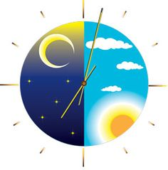
The light therapy component has 2 aims:
- Reduce the amount of body clock disruption that tends to occur during breast cancer treatment.
- Boost energy and alertness during times of fatigue.
Bright light is one of the strongest cues for synchronizing our body clocks and it is a critical factor in the regulation of sleep and wakefulness. Light therapy has been developed for the treatment of sleep difficulties and has been found to be very effective in regulating the body clock.
Bright light also helps you to feel energized and alert during the day, this can help you to cope with the fatigue associated with cancer treatments such as chemotherapy.

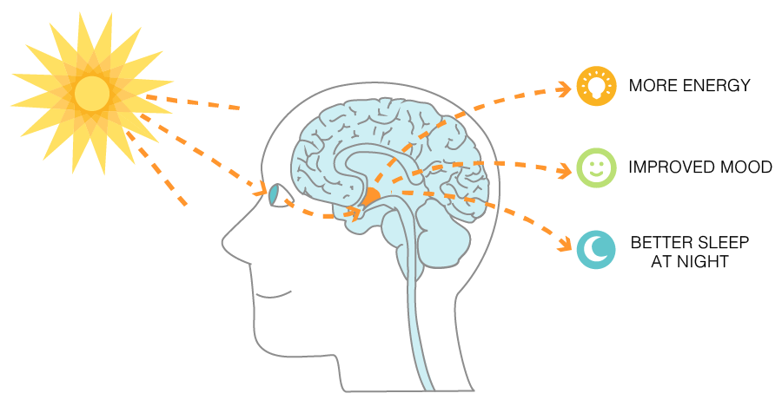

Reminders for how and when to use your light glasses:

- 30 minutes each morning, as soon after awakening as possible: Getting into a habit of using your light glasses whilst you eat breakfast could be helpful in creating a routine. Remember not to drive when wearing the glasses.
- At your usual rise time: Wear your glasses when you wake at your usual rise time, if you wake much earlier than usual, wait until your usual rise time to wear the glasses – refer to the ‘Quick Guide’ from your face to face session.
- Bright light boosts alertness and energy. Use the glasses for least 20 min when you feel fatigued or sleepy during the day, before the sun sets. Do not use the light glasses in the evening.

