Wearing your Actigraph
Where: Place the Actigraph on your non-dominant wrist with the Actigraph logo facing up, as you would wear a wrist watch.
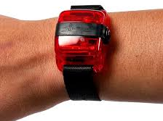

When: Wear your Actigraph at all times, both day and at night when you sleep.
Caution: although the watch is water resistant, it is best to take it off whilst showering.

Charging your Actigraph
You will receive your Actigraph with a fully charged battery. The battery lasts for approximately 25 days. As the program lasts for 6 weeks (42 days), you will need to charge your Actigraph once during this time. Actigraph re-charging will need to occur at around the same time as the mid-point phone call. Therefore, if required, we can walk you through the re-charging process over the phone.

To recharge your actigraph, you will need:

- A 10 cent coin

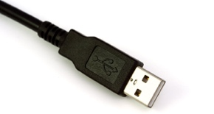
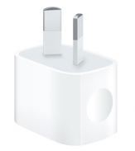
- The USB cable

- A USB port either from a PC, laptop or a USB wall charger

Follow these steps to recharge your Actigraph:

- Unscrew the USB port cover on the Actigraph by turning counter clockwise with a 10 cent coin (or any coin that fits)
- Use the USB cable to connect the Actigraph to the charging port (either in a computer or a wall charger)
- Leave the Actigraph to charge – whilst it is charging it will display a green flashing LED light.
- When the green light stops flashing and stays on constantly, the Actigraph is fully charged.

