CBT
+ Light
for Women
with Breast Cancer
Light glasses instruction manual
This document includes everything you need to know so that you can
get the best benefits from your light glasses.
Light therapy – essential information

What are the light glasses for?

The light therapy component of the cognitive behavioural and bright light sleep intervention aims to reduce the amount of body clock disruption that tends to occur during breast cancer treatment.
Bright light is one of the strongest cues for synchronizing our body clocks and it is vital in the regulation of sleep and wakefulness. Light therapy has been developed for the treatment of sleep difficulties and has been found to be very effective in regulating the body clock. 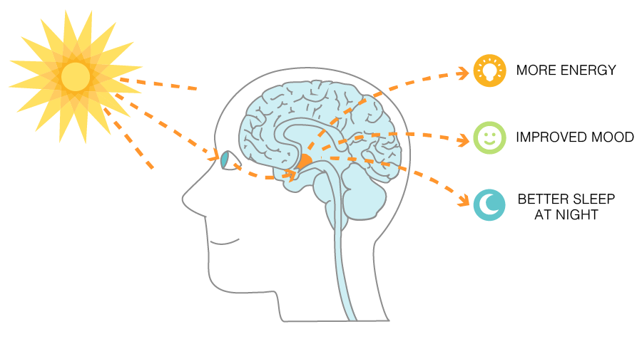
Using your light glasses when you wake up in the morning signals to your body that it is day time and helps you to feel more alert. Having these alerting signals early in the day will also help you to feel sleepy at a normal time in the evening. Meal times and exercise also help to regulate our body clock. Sometimes, during breast cancer treatment, you may not feel able to eat normally, exercise, or even move around much at all. On these days, using the light glasses is especially helpful. Even if your body clock isn’t getting its normal signals from food and exercise, the bright light in the morning will help to maintain its normal rhythm. As well as helping you fall asleep at night, the light glasses can help you to feel less fatigued during the day. This means that you may feel more energized and able to go about your day as you normally would, with less exhaustion and tiredness.

How do I use them?

Light Therapy Participant Guide
Be bright - get light - sleep tight!

Light Therapy has two main benefits:
- Boosts your mood and energy when you wake up, getting you started for your day
- Reduces feelings of grogginess and fatigue

Based on what we discussed during the meeting, please:
- Aim to get up around the same time every day – this will promote a healthy body clock.
- Use your glasses for at least 20 minutes (but no more than 30 minutes) at your usual wake time, which is: _______.
- Avoid bright light exposure (including using your glasses) in the evening/night (after 5pm). Use dim lamps and lights instead.
- Use the Night Shift mode or f.lux filter to block out blue light on electronic devices in the evening to minimise interference with your sleep.
- Do the above every day and consistently to get the best results and make the most out of the program!

A few additional notes that we discussed during our orientation:
- The best time to get light in the morning is the time you usually wake up. If you wake up later than usual, you may still use the glasses upon awakening. However, if you get up much earlier (more than 2 hours earlier), please wait till your usual wake time to use the light glasses.
- Opening your blinds in the morning is an excellent way of getting light, as is exposing yourself to natural light outside such as by going for a walk or exercising when the sun has risen.
- Try and expose yourself to natural bright light during the daytime
- If you usually wake up feeling alert and energetic, and are already getting up earlier than you wish to, you could adjust to use the glasses 2 hours after waking up.

Using Your Light Glasses

Your light glasses are very user-friendly. They are automatically locked at the highest setting (1500 lux), so there’s no need to change any settings. You should use the glasses in a well-lit room. There is detailed information and instructions of how to best use your glasses found in the Luminette User Manual.
Please watch the following YouTube video for a demonstration on how to use your glasses.

How to use Luminette® - Light therapy glasses:
https://www.youtube.com/watch?v=E-ErPb5Z5lM

Charging your glasses. Connect the micro-USB end to the slot in your glasses, and the other end (normal USB) into the wall charger. Plug in the adapter to charge (charge-time is 5 hours). The device will work best when it is fully charged, so please put it on charge when not in use. See page 14 of the User Manual for more information.

When charging: a single LED will flash slowly
When fully charged: the LED stops flashing and remains on
When there is an error: the LED flashes rapidly
Battery life. Correctly charged glasses will stay lit between 3-6 hours.

