Electronic Supplementary Material
Manual correction of metabolic rate for body mass
Our graphs are drawn using estimated marginal means from the final models. We note these graphs are qualitatively identical to those graphed using a manual correction method to account for variation in body mass, widely used in the field of eco-physiology. The manual correction method involves two steps. First, we built a linear ANCOVA model with the mean metabolic rate as the response variable and haplotype, sex and time of day of the assay as factors, along with body mass and ADS as covariates in the model. We then extracted the “coefficient estimate” for body mass from the summary of this linear model. In the second step, we employed this coefficient estimate for body mass to calculate the mass-corrected mean metabolic rate using the formula:
$$Corrected V̇̇CO2=Recorded V̇CO2+\left(Coefficient estimate\right)×\left(mean body mass-individual body mass\right)$$
In the formula, mean body mass for each sex was calculated and used to subtract with individual body mass based on the sex of the individual. The mean metabolic rate adjusted for body mass for each combination of haplotype and sex is shown below. This method allowed us to compare between the two methods of presenting metabolic rate data (that is, mass-corrected vs emmeans metabolic rate; ESM, Figure S1) and to investigate whether negative intersexual correlation, across haplotypes, for metabolic rate was upheld when calculating metabolic rate using this method (ESM, Figure S2). Note, this method does not account for sex-specific variation in activity, whereas the emmeans method we use in the main manuscript does. Note, the estimated marginal means are unitless. We confirmed that the two estimates were strongly positively correlated.

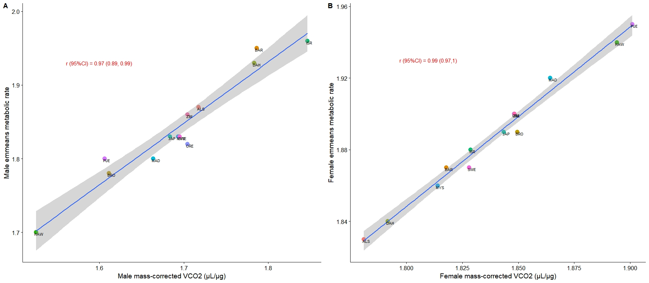

Figure S1. Correlation between mass-corrected V̇CO2 and marginal mean values estimated across the haplotypes. We derived the marginal mean values from the final model described in the main manuscript using emmeans in R.
Furthermore, the intersexual correlation for mass-corrected V̇CO2 was also strongly negative when using manually corrected mass-specific metabolic rates (Figure S2).
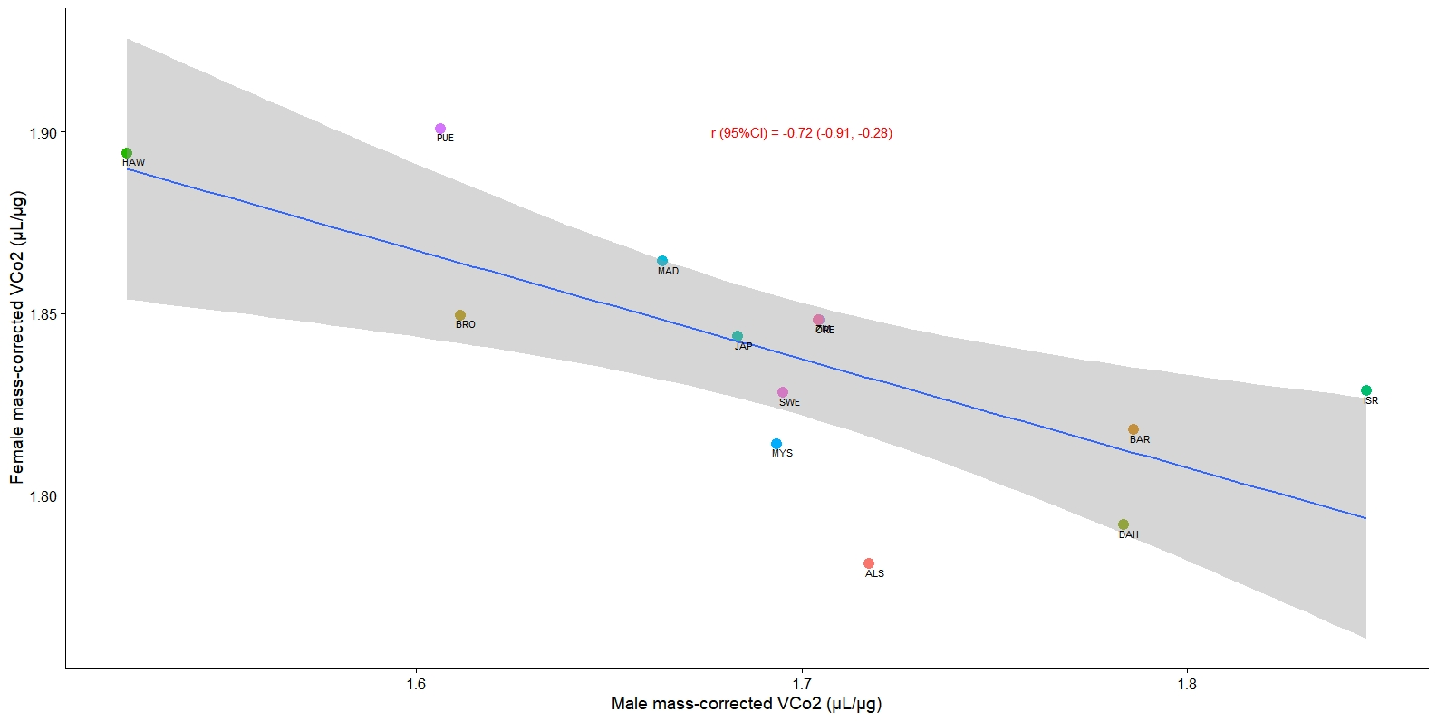
Figure S2. Intersexual mitochondrial genetic correlation for mass-corrected V̇CO₂ estimated using the manual correction method.

Correlation between body mass and longevity in each sex
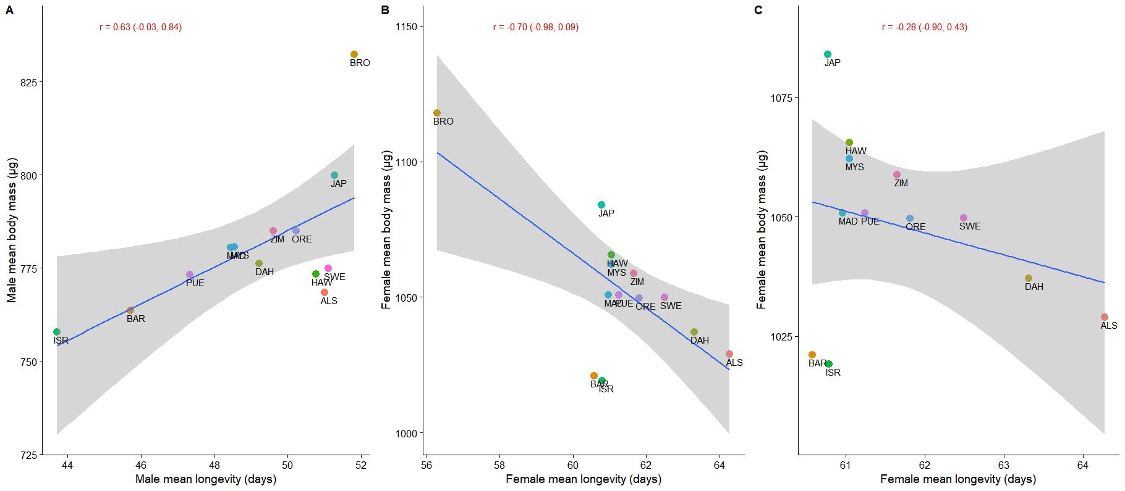
Figure S3. Intra-sexual mitochondrial correlation between mean body mass (µg) and mean longevity (days) for A) male and B) female flies across the panel of thirteen haplotypes. The correlation between these two traits was positive in males, but negative in females. However, in females, the exclusion of Brownsville haplotype (BRO) had an effect in the sign and direction of relationship between the two traits (shown in panel C). The scale in X- and Y-axes are adjusted across each panel to show the direction of relationship between the traits. Mean longevity data was leveraged from Camus et al., (2012). For annotations of each mtDNA haplotype – refer to Methods section. The Pearson’s correlation coefficient and bootstrapped 95% confidence intervals for each pairwise comparison is shown across all three panels in red fonts.

Correlation between metabolic rate, body mass and fertility traits in each sex
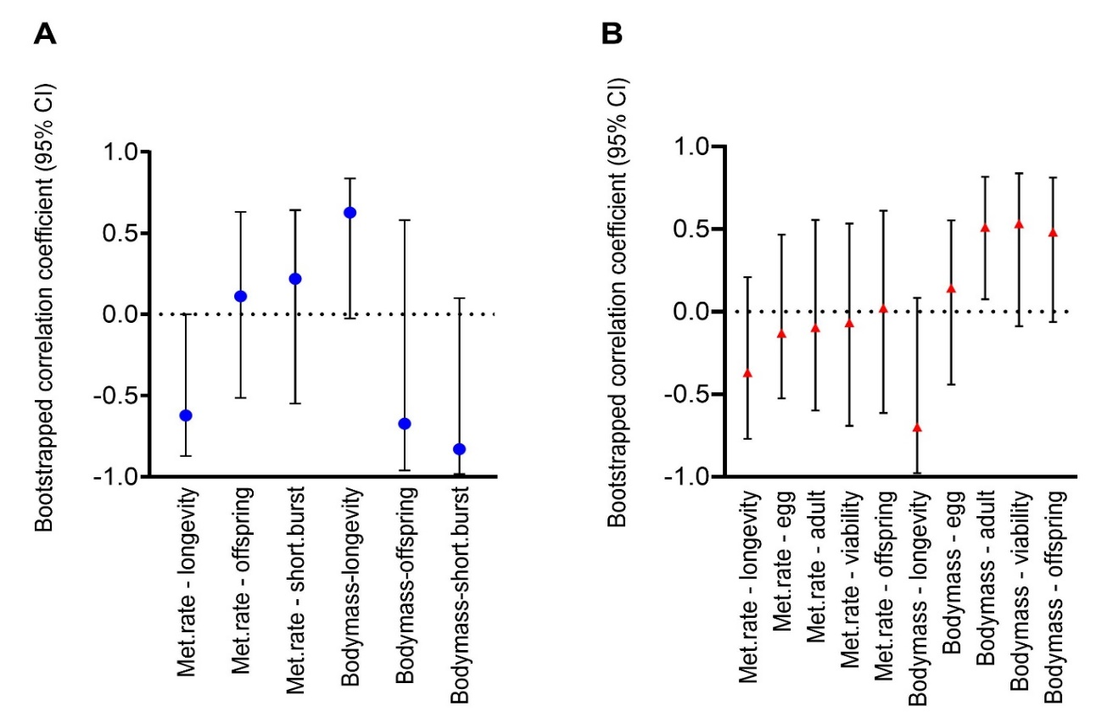

Figure S4: Intra-sexual mitochondrial genetic correlations across traits estimated using the non-parametric bootstrapping approach in boot function in R. The mitochondrial genetic correlation across traits (emmeans metabolic rate, body mass, longevity and reproductive traits) for males is presented in panel A and for females in panel B. The horizontal axis shows all pair-wise comparisons of life history and physiological traits. All measurements of metabolic rate and body mass were made in this study. In the horizontal axis: met.rate refers to the emmeans metabolic rate adjusted for body mass and ADS. Male and female longevity were extracted from Camus et al., (2012), whereas the reproductive traits were extracted from Camus et al., (2018). In panel A: male reproductive traits denoted as - offspring is male sustained offspring production; and short.burst is male short-burst offspring production. Whereas in panel B: female reproductive traits denoted as - egg is female short-burst fecundity; adult is female short-burst offspring production; viability is female short-burst viability; and offspring is sustained offspring production.

