Using your own money: Discussion guides for people with disability and their trusted service providers, support workers, family and friends
(Easy English)
This tool has been written for 3 reasons:
- To help people with disability to talk about their own money.
- To tell people where to get help if somebody is not using their money in the right way.
- To help people who want to help people with disability know what questions to ask
Support workers and other people, such as trusted friends or neighbours, can use this tool to help you. The tool can also be used by workers whose job it is to help people whose money is not being used in the right way.
Sometimes when people don’t use your money in the right way it is family violence. If people are not using your money in the right way there might be other family violence happening too. Using these questions might help you to think about whether somebody is not using your money in the right way. There are people who think that not using your money in the right way is OK. It is not OK and you should know that there are things to do and people who can help to stop it from happening.
There are 2 sets of questions. Each set has 2 lists:
The first list is called ‘Main questions’. This list is to help you find out if someone is not using your money in the right way. The second list is called ‘Extra questions’. This list has more questions to find out more about who uses your money.
The first set of questions can help you start thinking about your money.
The second set of questions helps you to think about how people haven’t used your money in the right way. When you are ready you can ask someone you trust to help you write this down.
If you think that someone is not using your money in the right way there is a list of phone numbers at the end to find you help.
These questions can be used by anybody with any kind of disability to see if someone is not using their money in the right way.
This is what it means when someone is not using your money in the right way:
When someone doesn’t use your money in the right way the Family Violence Protection Act 2008 (Vic) says that is wrong and that it is called financial abuse. This means that someone doesn’t let you use your own money the way you want to without a good reason, like you need money to pay bills when you only want to use it to go out.
The person who doesn’t let you use your own money in the way you want to can be a family member, including your parents, a child, or a friend, someone you live with or your support worker. The person doesn’t have to live with you. The person can also be a family member you don’t want to have anything to do with. And it can be someone who used to live with you.
Glossary
‘Financial abuse’ – When someone doesn’t let you use your own money in the way you want to. When someone uses your money in a way that is wrong.
‘In the right way’ – When things are done fairly. Using your money ‘in the right way’ might mean it is shared equally or that it is used in a way that feels right to you.
Set one questions
Main question | Extra questions
- Do you get told what to do, or where to go by someone?  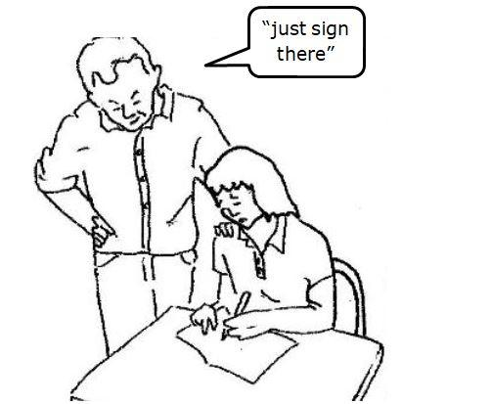 | Do they tell you when you can go out?  Do they tell you how long you can stay out?  Do they make you think you can’t do things?  Do they stop you from going out?  Do they stop you from seeing people?  Do they check your messages, emails, Facebook or Instagram?  Do they check what you are saying to people?  Do they check what people are saying to you?

- Do you have your own bank account and/or bank card?  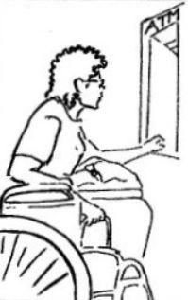 | Are you able to get your money out of your bank account yourself?  Are you able to use an ATM by yourself?  Does someone know your PIN number or passwords?  Is it OK to ask or talk about money?  Are you able to buy what you want when you want?  Can you buy your own clothes and other things like shampoo and makeup?  Do people talk to you about any changes in your home?  Do people talk to you when you need a wheelchair or other things like that?  Do people talk to you when you need to buy a computer or an iPad?  Does anyone stop you from using your things?  Does anyone make you feel like you can’t do things for yourself?  Does anyone make you feel like you can’t look after your own money?

- If you share your bank account with someone else is the money used in the right way?  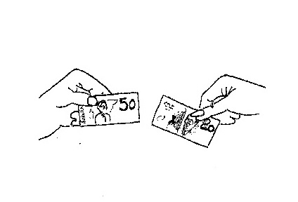 | Can you buy what you need when you need it?  Do you get to see what money goes in and out of your bank account?  Does the other person use more money than you from your shared bank account?  Do they buy more things than you?  Do they take more holidays than you?
- Does someone who uses your money have money problems?  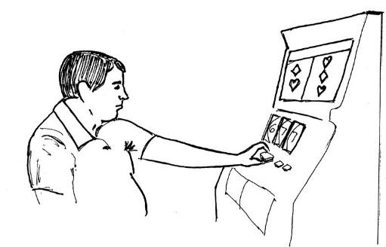 | Does the person have a gambling, drug or alcohol problem?  Has the person ever made you give them money for alcohol, drugs or gambling?  Have they asked you to buy alcohol or drugs for them?  Have you ever signed papers about money when you didn’t want to?  Have you ever signed papers about money that you didn’t understand?  Are the bills, like gas and electricity, in your name?  Do you have a credit card?  Does the other person use your credit card?  Does somebody get a loan for something they want and you have to pay for it?  Have you paid for this person’s bills?  Has the person ever taken your car and got a fine or toll bills, and you’ve had to pay for them?
- Does anyone tell you where you have to live?  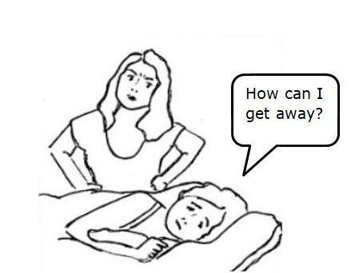 | Are you happy with where you live?  If you wanted to change houses what would stop you?  Are you worried what will happen if you try to get help?  Have you tried to get help before?  Are you worried about someone finding out you are asking for help?  Do you know what help you can get?
End set one questions

Where to get help
If somebody is not using your money in the right way you can get help from:
Women’s Information and Referral Exchange (WIRE)
Phone: | 1300 134 130 (9am to 5pm, Monday to Friday)
Email and online support: | www.wire.org.au  support@wire.org.au (9am to 5pm, Monday to Friday)
Walk-in Centre: | 372 Spencer Street West Melbourne (9.30am to 4.30pm, Monday to Friday). WIRE has an accessible toilet facility and an accessible entrance at the side of the building.

Set two questions
- Can you go to work when you want to?  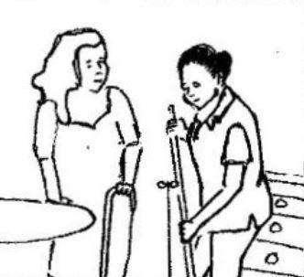 | If you work, are you paid for your work?  Do you get to keep the money?  Does anyone try to stop you from working?  Does anyone make trouble for you at your work?  Does someone try to stop you working because of your disability?  Does anyone make you work when you don’t want to?  Does anyone make you work when you are sick?  Are you happy with how much housework you do?  Are you happy with how much you are able to look after your children?  Do you have to look after other people, children or pets?  Do people make you do work for them?  Do they pay you for this work?

- Do you have to go to talk to the government or the courts?  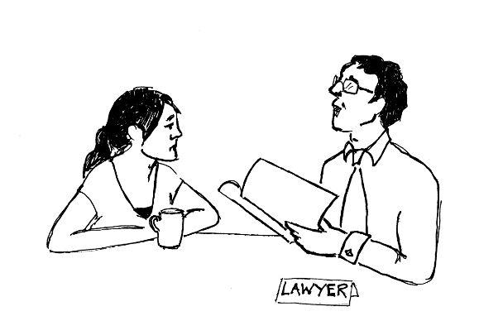 | Do you have any legal things happening with someone you live with, or used to live with?  Do you have any legal things happening with other people?  (Legal things can include decisions about divorce, children, property, guardianship or trusts).  Has anyone ever accused you of being violent or controlling or bossy?  Have you ever been told you are the person who is making trouble when you are not?  If you were not born in Australia are you allowed to stay here forever or on a visa?  Is the person who doesn’t use your money in the right way allowed to stay here forever?  Does anyone tell you that you might have to leave Australia if you don’t do what they say?  If you don’t speak English, do you use an interpreter?  Do you use an AUSLAN interpreter?  When you use an interpreter is it someone who is not using your money in the right way?
- If you have children are you allowed to, see them?  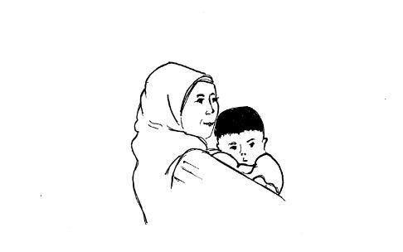 | If you get money from the government for your children do you have to give it to someone else?  Does anyone tell you what to do with your children or how to look after them?  Does anyone stop you from doing things for you children and do it themselves?  Does anyone ever tell you that someone might take your children from you?  Do you know that you can get help if you are a parent with a disability?

- Has anyone ever told lies about your disability?  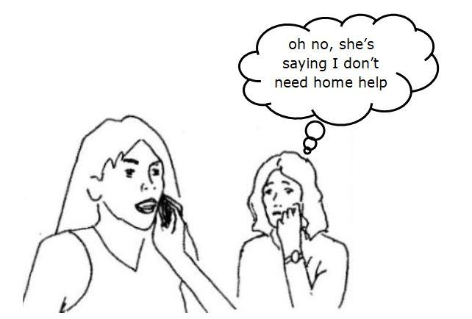 | Has anyone ever stopped you getting help or going to meetings?  Has anyone ever told you that you might lose your support worker or your wheelchair?  Has anyone ever put things like wheelchairs or medicine where you can’t reach them?  Do you know how much medicine you take?  Does anyone make you take more medicine than you need?  Does anyone make you take less medicine than you need?  Does anyone ever stop helping you when they should be helping?  Has anyone told you they will report you to Centrelink?  Has anyone made you prove you have a disability?
- Does anyone ever break or take your things or mess up your home?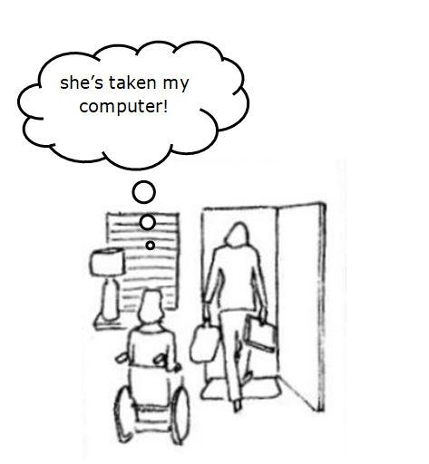 | Does anyone break or take your things?  Has anyone ever told you that because they pay for your things they own them, like your wheelchair or communication aids?  Has anyone taken your keys?  Has anyone tried to take your name off the rent papers?  Has anyone tried to tell the owner of the place you live to make you leave?  Has anyone stopped or said they would stop paying their share of the rent?  Has anyone tried to sell your house without you saying they can?
End set two questions
Where to get help
If someone is not using your money in the right way and you think financial abuse is happening, you can get help from these people.
Emergency
If someone is in immediate danger phone 000
Relay service
The National Relay Service (NRS) is a government initiative that allows people who are deaf, hard of hearing and/or have a speech impairment to make and receive phone calls. You can use the NRS numbers below to help you to contact other supports and services.
Speak and Listen number: | 1300 555 727
Teletypewriter (TTY) number: | 133 677
SMS Relay number: | 0423 677 767
Website: | https://www.communications.gov.au/what-we-do/phone/services-people-disability/accesshub/national-relay-service
Disability and family violence support
Safe Steps
The people who answer the phone can help you find help near to you.
Phone: | 1800 015 188 (24 hours, 7 days a week)
Email: | safesteps@safesteps.org.au
Website: | https://www.safesteps.org.au/
Disability and Family Violence Liaison Officer (Department of Health and Human Services)
Phone: | (03) 9843 6358 (9am-5pm, Monday to Friday)  0437 741 920 (9am-5pm, Monday to Friday)
Email: | Disabilityfv@dhhs.vic.gov.au
Website: | https://providers.dhhs.vic.gov.au/disability-and-family-violence-crisis-response
More information: | There is money called the ‘Disability and Family Violence Crisis Response Initiative’ which can provide immediate support for people with disability and children with disability to help them to access the supports required to be independent, either in their own home or in crisis accommodation if they don’t have money for that from the NDIS. Women with disability can also get money to help them find somewhere to live for a short time to help them leave violence. Some money can be used to help them work with a family violence case manager to develop a longer-term plan.  You can find out more by going to: https://providers.dhhs.vic.gov.au/disability-and-family-violence-crisis-response  To apply you can contact the Disability and Family Violence Liaison Officer.
Legal Aid
Victorian Legal Aid
Victorian Legal Aid has lawyers who can talk to you about how the law applies to your legal problem
Phone: | 1300 792 387 (8am to 6pm, Monday to Friday)
Website: | https://www.womenslegal.org.au/
Location: | VLA has 15 offices in Victoria. You can find where they are by going to their website:  https://www.legalaid.vic.gov.au/contact-us/our-offices
More information: | There are other ways to contact them for people with hearing or speech difficulties, including National Relay Service, instant messaging or mobile phone or tablet if you have an internet connection: https://www.legalaid.vic.gov.au/contact-us/help-for-people-with-hearing-or-speech-difficulties  People who don’t speak English can get help using this website: https://www.legalaid.vic.gov.au/contact-us/speak-to-us-in-your-language
Women’s Legal Service Victoria
The Women’s Legal Service works with women who need help because they are poor or have a disability. They can help women with legal issues because of divorce, separation or violence.
Phone: | 03 8622 0600 (for city callers) (5:30pm to 8:00pm, Tuesday and Thursday)  1800 133 302 (for country callers) (5:30pm to 8:00pm, Tuesday and Thursday)  Interpreter services are available
Location: | Level 6, Melbourne Magistrates’ Court  233 William Street (which is on the corner of Lonsdale St)  Melbourne 3000
Website: | https://www.womenslegal.org.au/
Multicultural Centre Against Family Violence
InTouch
InTouch is a family violence service that is good at working with women who don’t speak English, their families and the people in their communities. They provide case management, training, and they conduct research, and run community-based projects in order to stop family violence in the community.
Phone: | 1800 755 988 (toll free number) (9:00am to 5:00pm, Monday to Friday)  03 9413 6500 (9:00am to 5:00pm, Monday to Friday)
Email: | https://intouch.org.au/contact-us/
Website: | https://intouch.org.au/
Counselling

1800RESPECT

1800RESPECT is the National Sexual Assault, Domestic Family Violence Counselling Service. They offer confidential information, counselling and support. 1800RESPECT is open 24 hours to support people impacted by sexual assault, domestic or family violence and abuse.
Phone: | 1800 737 732 (24 hours, 7 days a week)
Online chat: | https://chat.1800respect.org.au/#/welcome
Website: | https://www.1800respect.org.au/
More information: | Smartphone app  1800RESPECT also has a smartphone app called Sunny. Sunny helps women with disability learn about violence, learn about rights, and helps women with disability find the right support. The Sunny app is free and available now for iPhone. Download the Sunny App on the Apple App Store or visit https://www.1800respect.org.au/sunny
Help with money
National Disability Insurance Scheme – or NDIS
Phone: | 1800 800 110
Location: | Find an office location on this website: https://www.ndis.gov.au/contact/locations
Website: | https://www.ndis.gov.au/applying-access-ndis/how-apply
More information: | The NDIS can give special money if you have a disability or your child has a disability to buy the supports you need like wheelchairs, or someone to help you get out of bed, or to have a shower, or help to get into the community. You have to be 65 years or younger, and have a disability which is going to always be there, and you have to be allowed to live in Australia forever, and you can’t get the money from somewhere else, like insurance money if you have had an accident.  If you are already in the NDIS, you can get extra money if you need it because of domestic or family violence. You can do this by asking for a Change of Circumstance Form.  If you are not already in the NDIS, you have to phone the NDIS to ask for an Access Request. Once they say you can be in the NDIS, they will invite you to come to their office to talk about what you need. You can phone 1800 800 110 to make an Access Request or you can ask for a form to fill out or if you need a Change of Circumstances form.  If you need help filling it out the form or making the call, you can contact your Local Area Coordinator, Early Childhood Early Intervention partner or your contact your local NDIA office.
National Debt Helpline
You can get help with your money or if you owe money by ringing the National Debt Helpline.
Phone: | 1800 007 007 (9:30 am to 4:30 pm, Monday to Friday)
Website: | http://www.ndh.org.au/
Crisis payment - Extreme circumstances or domestic violence (Department of Human Services)
A one off payment if you’re in severe financial hardship and extreme circumstances.
Phone: | 132 850 (8:00 am to 5:00 pm, Monday to Friday)
Location: | Find a service centre on this website: https://findus.humanservices.gov.au/findnearest.asp
Website: | https://www.humanservices.gov.au/individuals/services/centrelink/crisis-payment
More information: | To apply download this form - https://www.humanservices.gov.au/sites/default/files/documents/su510-1512en.pdf
Money Smart (ASIC)
Phone: | 1300 300 630
Website: | https://www.moneysmart.gov.au/managing-your-money/managing-debts/trouble-with-debt/urgent-money-help
More information: | Urgent money help  If you are don’t have enough money to pay your bills or your rent or afford food, there are people who can help you. This includes emergency money, income support like a pension or the dole and even support if you are sad and practical advice; help with finding somewhere to live and help to pay loans or bills. To find out more go to  https://www.moneysmart.gov.au/managing-your-money/managing-debts/trouble-with-debt/urgent-money-help  Divorce and separation  When you split up with your partner or husband, it can be very hard. You might feel sad, angry or hurt. You may feel worried or that it is very hard about such a big change in your life. Ask for help if you need it. Start by thinking about what is most important , like having your own bank account, then think about other things you might need You can visit  https://www.moneysmart.gov.au/life-events-and-you/life-events/divorce-and-separation
Payments for people who have an illness, injury or disability (Australian Government Department of Human Services)
The Department of Human Services provides money and help to help you if you have an illness, injury or disability that means you can’t work, or can only do a little bit of work.
Phone: | 132 717 (8:00am to 5:00pm, Monday to Friday)
Location: | Find a Centrelink office on this website https://findus.humanservices.gov.au/findnearest.asp
Website: | https://www.humanservices.gov.au/individuals/subjects/payments-people-living-illness-injury-or-disability
More information: | Disability Support Pension  You can get money and help if you have a physical, intellectual or psychiatric disability that will last forever, and that stops you from working. Get more information from  https://www.humanservices.gov.au/individuals/services/centrelink/disability-support-pension  Mobility Allowance  You can get money to help pay for travelling to work, to school or to help you look for work if you have a disability, illness or injury that means you can’t use public transport. Get more information from  https://www.humanservices.gov.au/individuals/services/centrelink/mobility-allowance  Sickness allowance  You can get some money if you can’t work for a little while or an income support payment if you can’t work or study for a while because of illness, injury or disability.  https://www.humanservices.gov.au/individuals/services/centrelink/sickness-allowance  If you can’t fill in the form on the website, you can call the people with disability phone number 132 717, Monday to Friday, 8:00am - 5:00pm. You can also visit a CentreLink Office. To find one go to this website https://findus.humanservices.gov.au/findnearest.asp  Financial support if your child or children have disability  Child Disability Assistance Payment  An automatic yearly payment if you get Carer Allowance from 1 July and are looking after a child with a disability or serious illness.  https://www.humanservices.gov.au/individuals/services/centrelink/child-disability-assistance-payment  Youth Disability Supplement  An extra payment if you’re a young person with disability and on an income support payment.  https://www.humanservices.gov.au/individuals/services/centrelink/youth-disability-supplement
Concessions
Companion Card | The Companion Card helps the rights of people with a disability, by paying for tickets for a person to go with you to show or concert, if you have to have someone with you. You can find out more if you go to this website.  http://www.vic.companioncard.org.au/
Other concessions | In Victoria there is help to pay bills like your gas or electricity bill if you have a low income or have no money. To find out more go to this website:https://services.dhhs.vic.gov.au/concessions-and-benefits
Carer and family support payments (Victorian Department of Health and Human Services)
The Victorian Department of Health and Human Services Disability Intake and Response Service provides money and help to families of children with a disability and carers of adults with a disability.
Phone: | 1800 783 783 (9:00am to 5:00pm, Monday to Friday)  TTY 1800 008 149 (9:00am to 5:00pm, Monday to Friday)
Website: | https://services.dhhs.vic.gov.au/carer-and-family-support
Accommodation
1800RESPECT

1800RESPECT is the National Sexual Assault, Domestic Family Violence Counselling Service. They can help you find support and give you advice about where to live.
Phone: | 1800 737 732 (24 hours, 7 days a week)
Online chat: | https://chat.1800respect.org.au/#/welcome
Website: | https://www.1800respect.org.au/
More information: | Smartphone app  1800RESPECT also has a smartphone app called Sunny. Sunny helps women with disability learn about violence, learn about rights, and helps women with disability find the right support. The Sunny app is free and available now for iPhone. Download the Sunny App on the Apple App Store or visit https://www.1800respect.org.au/sunny
Women With Disabilities Victoria
WDV can give you advice about who to ask about where to live.
Phone: | (03) 9286 7800 (9:00am to 5:00pm, Monday to Thursday)
Website: | https://www.wdv.org.au/contact-us/
Summer Foundation and The Housing Hub
The Summer Foundation have a lot of help about where to live including The Housing Hub which helps people with disability find housing vacancies as well as a tool to help people decide where they want to live.
Phone: | 1300 626 560
Email: | info@summerfoundation.org.au
Website: | https://www.summerfoundation.org.au/project/thehousinghub/
More information: | To help make decisions about where to live, go to Housing Preferences here - https://www.summerfoundation.org.au/resources/my-housing-preferences/
The Office of Housing Victoria
The Office of Housing Victoria can provide people to help find money or help if you are in danger now or escaping family violence or at risk of homelessness.
Phone: | 1800 825 955 (24 hours a day, 7 days a week)
Website: | https://www.housing.vic.gov.au/contacts
Advice and advocacy
Department of Social Services – National Disability Advocacy Program
Website: | https://www.dss.gov.au/our-responsibilities/disability-and-carers/program-services/for-people-with-disability/national-disability-advocacy-program-ndap
Email: | disabilityadvocacy@dss.gov.au
Further information: | The National Disability Advocacy Program (NDAP) provides people with disability with access to someone who can help with their advocacy to help them get equal enjoyment of all human rights and community participation.  Advocacy for people with disability can be speaking, acting or writing for the person with a disability or a group of people with disability. about justice for the person or group by:  - being on their side and no one else's;  - Talking about their needs;  - Remaining loyal to the person with a disability and speaking for and to them in a way which shows they understand (while understanding the rights of others); and  - Making sure that they put the person in no danger  Watch the information video – https://www.dss.gov.au/our-responsibilities/disability-and-carers/publications-articles/national-disability-advocacy-program-advocacy-for-people-with-disability-dvd
The Office of the Public Advocate (OPA) Advice Service
Phone: | 1300 309 337 (9:00am to 4:45pm, Monday to Friday)  TTY: 1300 305 612  If the Advice Service telephone line is busy, you can leave your details and someone will ring you back as soon as they can. Mostly they ring back within an hour.
Email: | OPA_Advice@justice.vic.gov.au
Location: | Level 1, 204 Lygon Street, Carlton Victoria 3053
Website: | https://www.publicadvocate.vic.gov.au/about-us/contact-us
More information: | OPA’s team of highly trained staff can provide advice on a big range of things that worry people with disability, including:  - Someone to look after you and your things  - Enduring powers of attorney, someone to help make decisions  - Medical treatment decision-making, someone to make sure you get the right help when you are sick.  - Help you with the OPA's Community Visitors Program.
Disability Services Commissioner (Victoria)
Phone: | 1800 677 342  TTY: 1300 726 563
Email: | complaints@odsc.vic.gov.au
Website: | https://www.odsc.vic.gov.au/about-us/contact-us/
More information: | If you are experiencing a problem with someone who is supposed to work for you, like a service provider you can phone the Disability Services Commissioner and they will tell you how to get help. If it is violence or someone misusing your money they will do an investigation. If you need help now they will help you contact the right people.

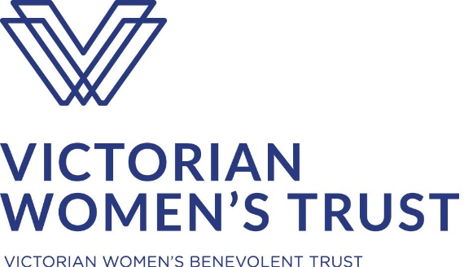

Identifying economic abuse amongst women with disability in Victoria: A toolkit for service providers and people experiencing family violence
The Monash Gender and Family Violence Prevention Centre in partnership with Tricia Malowney OAM. Supported by the Victorian Women’s Benevolent Trust.
Acknowledgments
The research team would like to thank the women who participated in the focus groups and final consultation as well as those who shared their stories with us for the original ANROWS-funded research upon which this project is based. We would also like to extend our thanks to the numerous stakeholders and experts who contributed so generously during the focus groups and afterwards.
We thank the Victorian Women’s Benevolent Trust for funding this project as part of their small grants program in 2018-2019. We would also like to acknowledge the ANROWS funding for Women Disability and Violence: Creating Access to Justice that began this work and we would like to thank members of the research team with whom we worked on this project, Dr Claire Spivakovsky and Professor Jude McCulloch from Monash University, Kara Beavis from Oueensland University of Technology, and Dr Jessica Cadwallader, Meredith Lea and Therese Sands from People with Disability Australia.

