How to download the Leipzig corpus file for the paper.
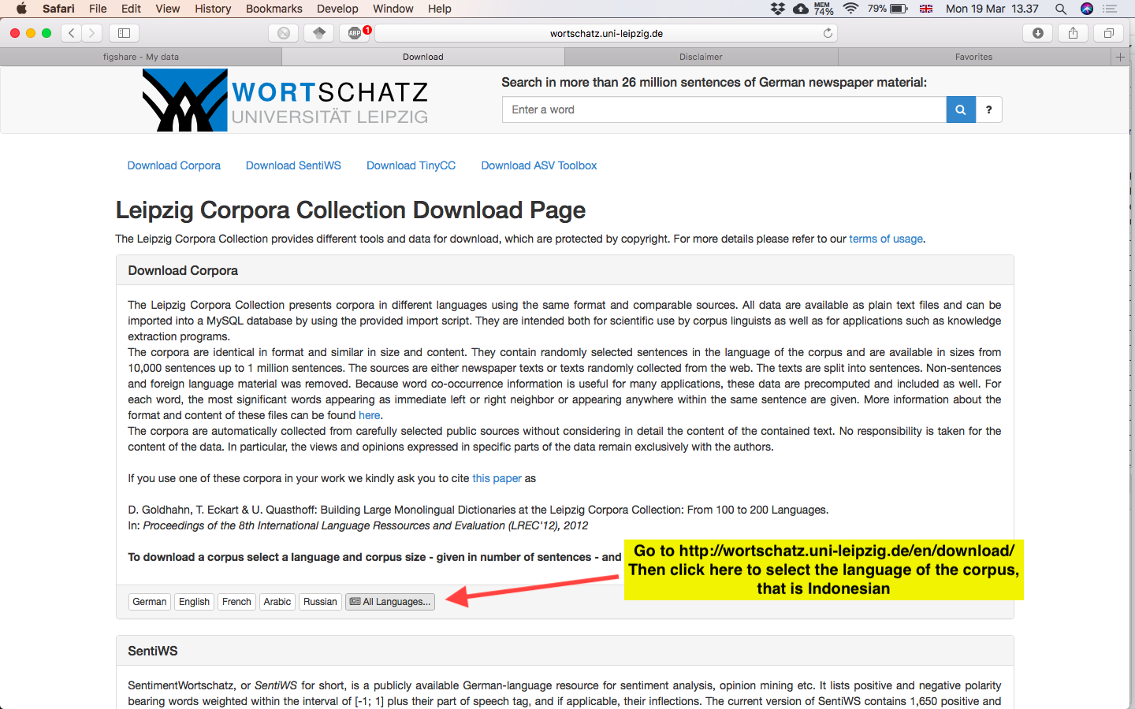
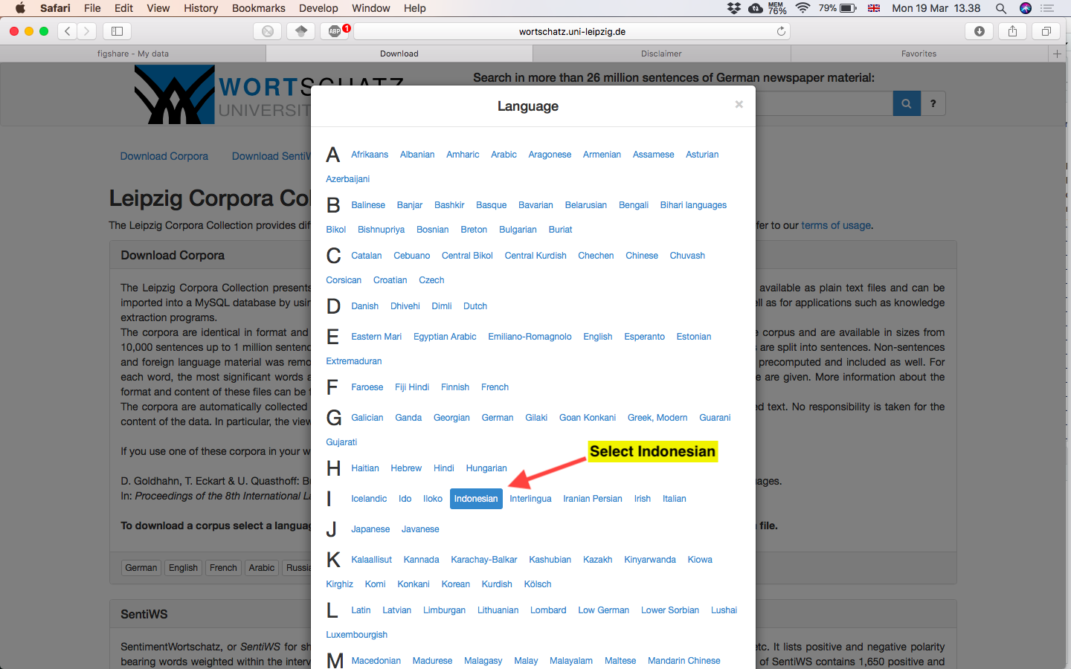

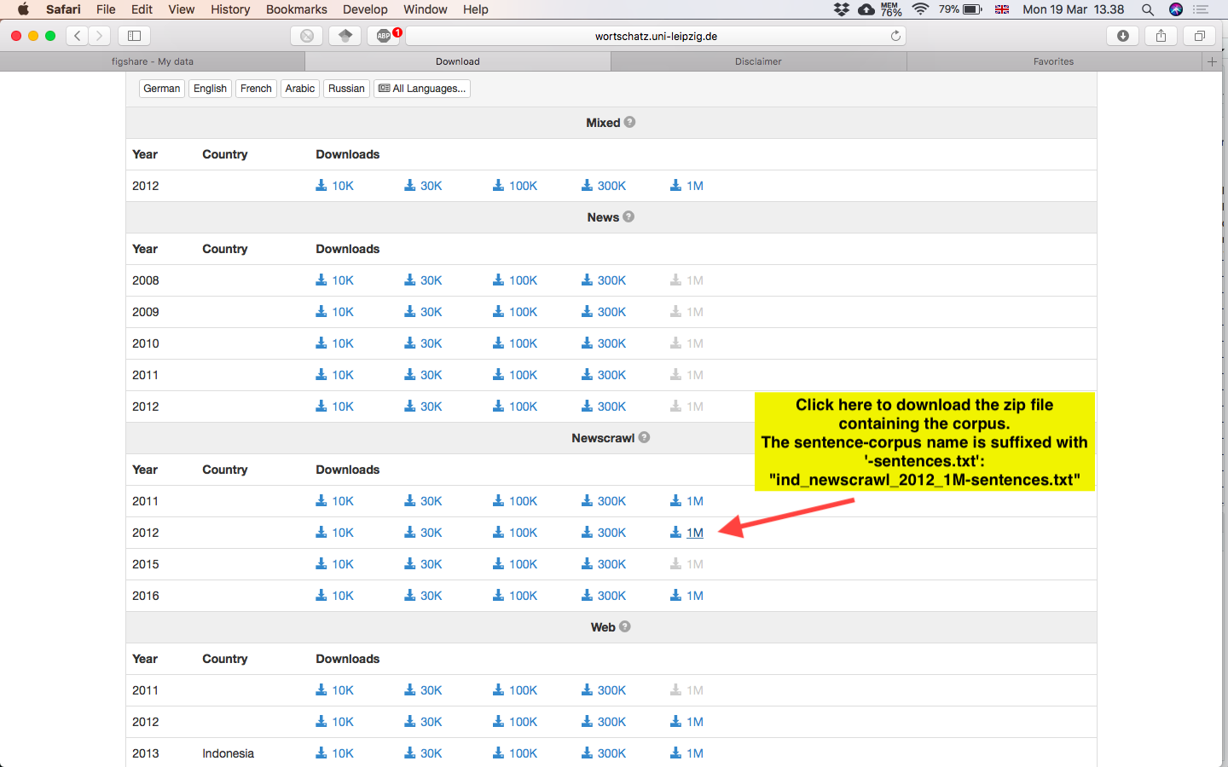

Unzip the folder and put “ind_newscrawl_2012_1M-sentences.txt” in the same folder with the R Markdown document and the other datasets.

